

**Service Mesh Installation and Configuration   
with Istio on Kubernetes**

**Version History**

|  |  |  |  |  |  |
| --- | --- | --- | --- | --- | --- |
| SI | Date | Ver | Description | Changed by | Approved/Reviewed by |
| 01 | 03-Feb-22 | 1.0 | Service Mesh Installation and Configuration  with Istio on Kubernetes | Maidul Islam  Software Engineer | Md. Mahedee Hasan  Head of Software Development |

Contents

Introduction 4

Istio 4

Installation Steps 5

1.0 Download Istio 5

1.1 Verify Istio 6

1.2 Configure auto Proxy Injection 6

1.3 Check what's Running 6

Deploying an Istio-managed App 7

1.0 Deploy BookInfo 7

1.1 Verify the install 13

1.2 Check pods have proxy auto-injected 14

Using Istio for fault-tolerance 14

1.0 Route traffic through Istio 14

1.1 Update virtual service with timeout 16

1.2 Update virtual service with retry 16

Configuration of Dark Launch 17

1.0 Pre-reqs 17

1.1 Deploy v2 17

1.2 Switch to Dark Launch 19

1.3 Test with Network Delay 21

Configuration of Blue/Green Deployment 22

1.0 Pre-reqs 24

1.1 Deploy v2 24

1.2 Blue/Green deployment – Flip 28

1.3 Blue/green deployment - flip back 29

Configuring Canary Deployment 30

1.0 Canary deployment with 30% traffic to v2 31

1.1 Canary Rollout 33

55/45 split 33

25/75 split 34

0/100 split 34

1.2 Canary with Sticky Session 35

Configuration of Circuit Breaker 36

1.0 Pre-reqs 37

1.1 V2 Details Service 37

1.2 Apply Circuit Breaker 40

Visualizing the Service Mesh 41

Telemetry flow through Istio 41

1.0 Pre-reqs 43

1.1 View the Dashboard 43

1.2 Publish the Kiali UI 44

Monitoring with Prometheus & Grafana 50

1.0 Publish the Prometheus UI 50

1.2 Publish the Grafana UI 52

Distributed Tracing 54

1.0 Publish the Jaegar UI 55

Logging from Istio and Envoy 57

1.0 Deploy the Logging Stack 58

1.1 Configure Istio to Log to Fluentd 67

References 69

# Introduction

is a way to control how different parts of an application share data with one another. Unlike other systems for managing this communication, a service mesh is a dedicated infrastructure layer built right into an app. This visible infrastructure layer can document how well (or not) different parts of an app interact, so it becomes easier to optimize communication and avoid downtime as an app grows.

Modern applications are often broken down in this way, as a network of services each performing a specific business function. In order to execute its function, one service might need to request data from several other services. But what if some services get overloaded with requests, like the retailer’s inventory database? This is where a service mesh comes in—it routes requests from one service to the next, optimizing how all the moving parts work together.

# Istio

Istio is an open platform for providing a uniform way to integrate microservices, manage traffic flow across microservices, enforce policies and aggregate telemetry data. Istio's control plane provides an abstraction layer over the underlying cluster management platform, such as Kubernetes, Mesos, etc.

Managing traffic is one of the core features of Istio and it is really important to good understanding of the three resources that Istio uses.

1. Gateway – External traffic comes through gateway into the cluster and bring into the service mesh, so the rules apply.
2. Virtual Services – Virtual Service can be bound to the gateway. End-user traffic comes through the gateway into the virtual service, and Istio’s rules apply.
3. Destination Rule – it configured exactly where traffic gets routed and how the network treats that traffic.

**Prometheus:**

Monitoring tool and it monitor everything in a cluster.

**Grafana:**

It is data visualization tools for matrix data.

**Jaeger-collector and tracing:**

Service for tracing microservice request.

**Zipkin**

Zipkin is alternative of Jaeger.

# Installation Steps

These steps require you to have a cluster running a supported version of Kubernetes (1.19, 1.20, 1.21, 1.22).

## 1.0 Download Istio

1. Open Git Bash or Powershell.
2. Go to below link download the installation file for your OS,

<https://github.com/istio/istio/releases/tag/1.12.2>

or download and extract the latest release automatically (Linux or macOS):

curl -L https://istio.io/downloadIstio | sh -

1. Move to the Istio package directory. For example, if the package is istio-1.12.2.

cd istio-1.12.2

The installation directory contains:

* Sample applications in samples/
* The istioctl client binary in the bin/ directory.

1. Add the istioctl client to your path (Linux or macOS):

export PATH=$PWD/bin:$PATH

***Note: above command need to use for every single Git Bash or Powershell or other tool.***

1. For this installation, we use the demo configuration profile. It’s selected to have a good set of defaults for testing, but there are other profiles for production or performance testing. Use below command to install Istio.

istioctl install --set profile=demo -y

## 1.1 Verify Istio

1. Use below command to verify the running objects of istio system.

kubectl get all -n istio-system

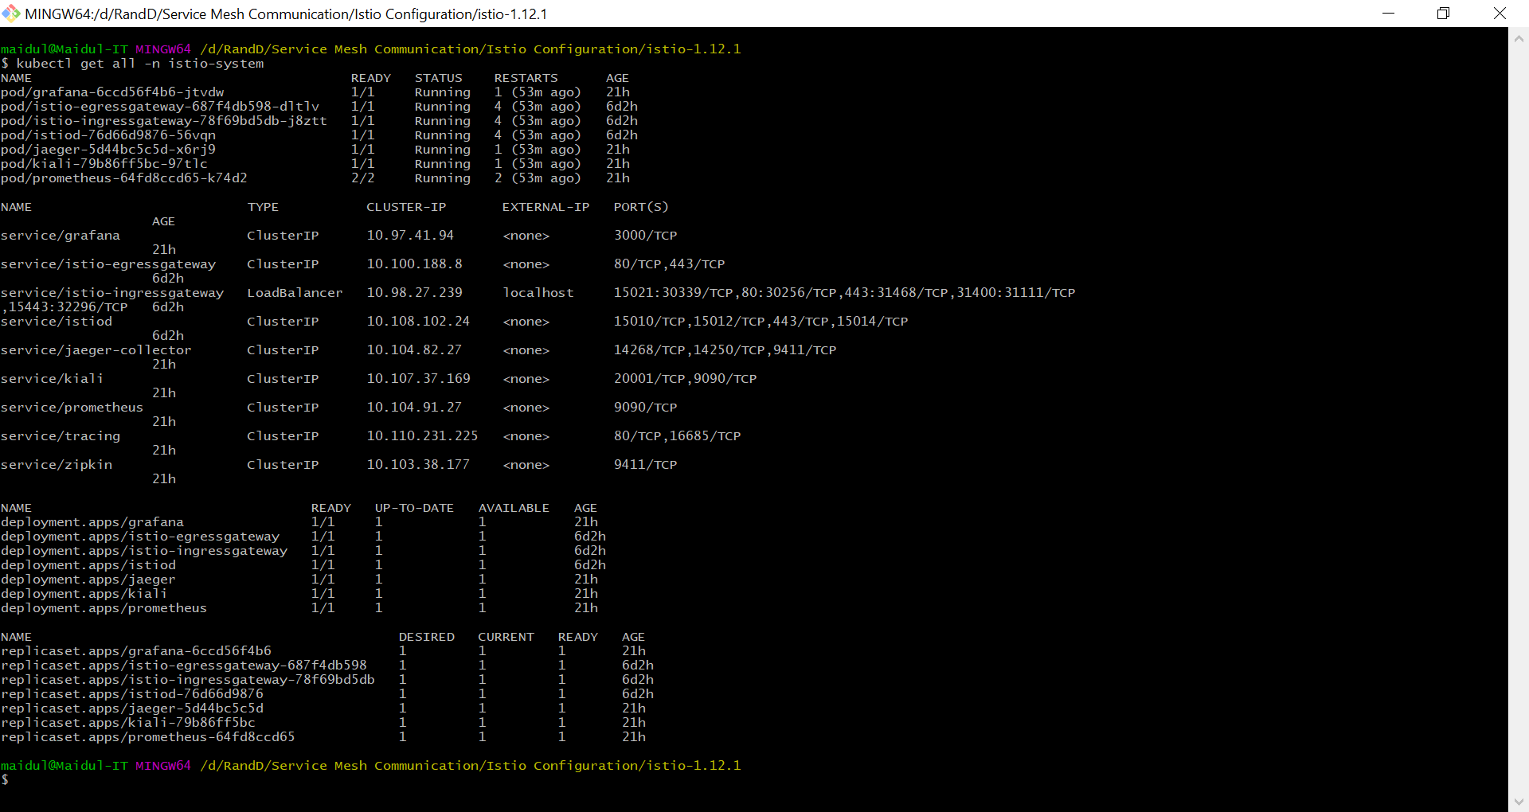

All components have memory requests

## 1.2 Configure auto Proxy Injection

1. Add a namespace label to instruct Istio to automatically inject Envoy sidecar proxies when you deploy your application later. Use below command to configure default namespance with Istio sidecar proxy.

kubectl label namespace default istio-injection=enabled

1. Check label by using below command

kubectl describe namespace default

## 1.3 Check what's Running

1. Check all running pods deployments and services with below command.

kubectl get all

Check with below command if you are using docker desktop kubernetes.

docker info

# Deploying an Istio-managed App

## 1.0 Deploy BookInfo

Now we are going to deploy a sample application.

1. Create a YAML file and name the file **bookinfo-v1.yaml** and write below code.

##################################################################################################

# Details service

##################################################################################################

apiVersion: v1

kind: Service

metadata:

  name: details

  labels:

    app: details

    service: details

spec:

  ports:

    - port: 9080

      name: http

  selector:

    app: details

---

apiVersion: v1

kind: ServiceAccount

metadata:

  name: bookinfo-details

  labels:

    account: details

---

apiVersion: apps/v1

kind: Deployment

metadata:

  name: details-v1

  labels:

    app: details

    version: v1

spec:

  replicas: 1

  selector:

    matchLabels:

      app: details

      version: v1

  template:

    metadata:

      labels:

        app: details

        version: v1

    spec:

      serviceAccountName: bookinfo-details

      containers:

        - name: details

          image: docker.io/sixeyed/bookinfo-details:v1

          imagePullPolicy: IfNotPresent

          ports:

            - containerPort: 9080

---

##################################################################################################

# Ratings service

##################################################################################################

apiVersion: v1

kind: Service

metadata:

  name: ratings

  labels:

    app: ratings

    service: ratings

spec:

  ports:

    - port: 9080

      name: http

  selector:

    app: ratings

---

apiVersion: v1

kind: ServiceAccount

metadata:

  name: bookinfo-ratings

  labels:

    account: ratings

---

apiVersion: apps/v1

kind: Deployment

metadata:

  name: ratings-v1

  labels:

    app: ratings

    version: v1

spec:

  replicas: 1

  selector:

    matchLabels:

      app: ratings

      version: v1

  template:

    metadata:

      labels:

        app: ratings

        version: v1

    spec:

      serviceAccountName: bookinfo-ratings

      containers:

        - name: ratings

          image: docker.io/istio/examples-bookinfo-ratings-v1:1.15.0

          imagePullPolicy: IfNotPresent

          ports:

            - containerPort: 9080

---

##################################################################################################

# Reviews service

##################################################################################################

apiVersion: v1

kind: Service

metadata:

  name: reviews

  labels:

    app: reviews

    service: reviews

spec:

  ports:

    - port: 9080

      name: http

  selector:

    app: reviews

---

apiVersion: v1

kind: ServiceAccount

metadata:

  name: bookinfo-reviews

  labels:

    account: reviews

---

apiVersion: apps/v1

kind: Deployment

metadata:

  name: reviews-v1

  labels:

    app: reviews

    version: v1

spec:

  replicas: 1

  selector:

    matchLabels:

      app: reviews

      version: v1

  template:

    metadata:

      labels:

        app: reviews

        version: v1

    spec:

      serviceAccountName: bookinfo-reviews

      containers:

        - name: reviews

          image: docker.io/istio/examples-bookinfo-reviews-v1:1.15.0

          imagePullPolicy: IfNotPresent

          ports:

            - containerPort: 9080

---

##################################################################################################

# Productpage services

##################################################################################################

apiVersion: v1

kind: Service

metadata:

  name: productpage

  labels:

    app: productpage

    service: productpage

spec:

  ports:

    - port: 9080

      name: http

  selector:

    app: productpage

---

apiVersion: v1

kind: ServiceAccount

metadata:

  name: bookinfo-productpage

  labels:

    account: productpage

---

apiVersion: apps/v1

kind: Deployment

metadata:

  name: productpage-v1

  labels:

    app: productpage

    version: v1

spec:

  replicas: 1

  selector:

    matchLabels:

      app: productpage

      version: v1

  template:

    metadata:

      labels:

        app: productpage

        version: v1

    spec:

      serviceAccountName: bookinfo-productpage

      containers:

        - name: productpage

          image: docker.io/sixeyed/bookinfo-productpage:v1

          imagePullPolicy: IfNotPresent

          ports:

            - containerPort: 9080

---

1. Now execute yaml file with below command.

kubectl apply -f bookinfo-v1.yaml

1. Verify the deployment with below command.

kubectl get po -w

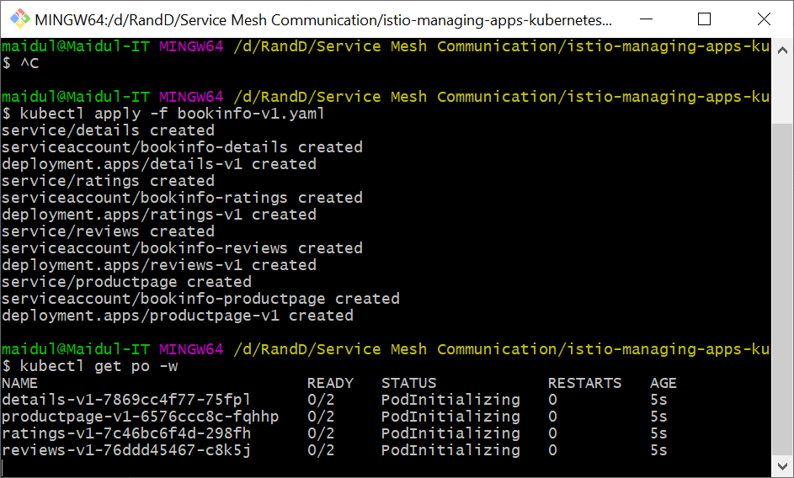

1. Now create another YAML file to deploy gateway, name the file **bookinfo-gateway.yaml** and write below code.

apiVersion: networking.istio.io/v1alpha3

kind: Gateway

metadata:

  name: bookinfo-gateway

spec:

  selector:

    istio: ingressgateway # use istio default controller

  servers:

  - port:

      number: 80

      name: http

      protocol: HTTP

    hosts:

    - "*"

---

apiVersion: networking.istio.io/v1alpha3

kind: VirtualService

metadata:

  name: bookinfo

spec:

  hosts:

  - "*"

  gateways:

  - bookinfo-gateway

  http:

  - match:

    - uri:

        exact: /productpage

    - uri:

        prefix: /static

    - uri:

        exact: /login

    - uri:

        exact: /logout

    - uri:

        prefix: /api/v1/products

    route:

    - destination:

        host: productpage

        port:

          number: 9080

1. Execute above file with below command to generate Gateway..

kubectl apply -f bookinfo-gateway.yaml

## 1.1 Verify the install

1. Check Gateway pods with below command.

kubectl get svc istio-ingressgateway -n istio-system

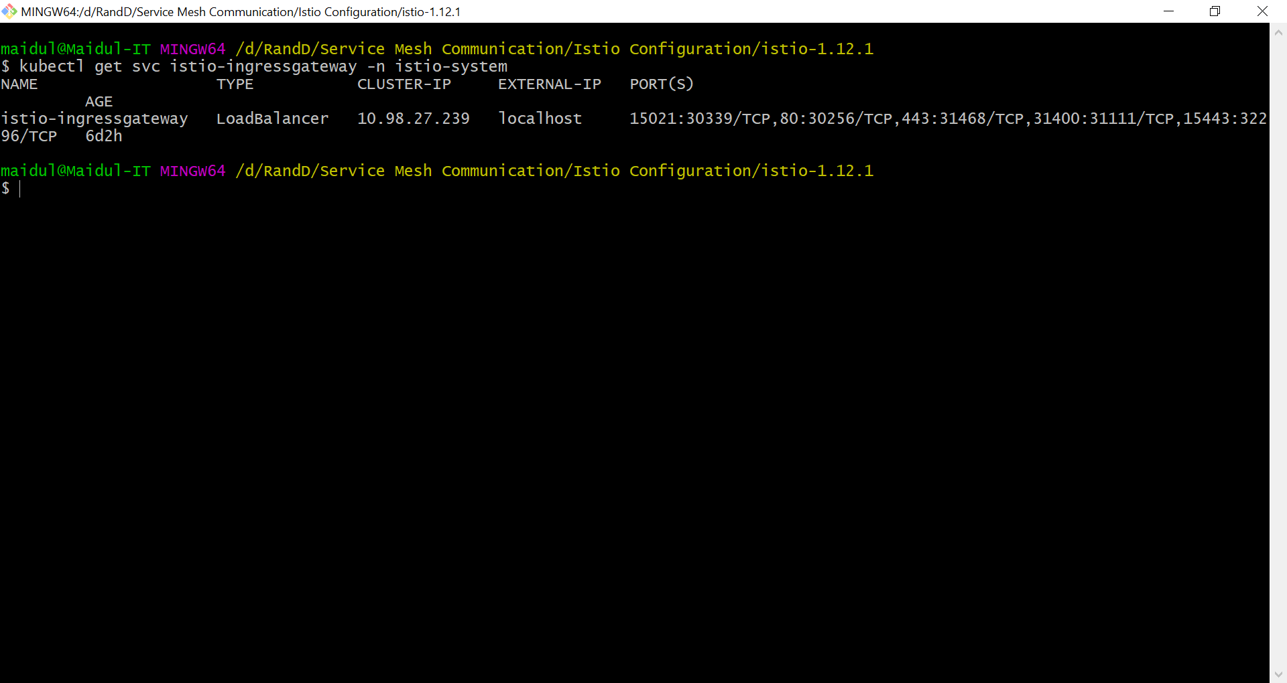

1. Go to below link and check if it is working.

<http://localhost/productpage>

## 1.2 Check pods have proxy auto-injected

1. Show the productpage proxy setup with below command.

kubectl describe pods -l app=productpage

1. Find all proxy containers -

docker container ls --filter name=istio-proxy_*

1. Check proxy processes for the product page:

docker container ls --filter name=istio-proxy_productpage* -q

# Using Istio for fault-tolerance

## 1.0 Route traffic through Istio

1. Create a YAML file to deploy and name the file **details-virtualservice.yaml** and write below code.

apiVersion: networking.istio.io/v1alpha3

kind: VirtualService

metadata:

  name: details

spec:

  hosts:

  - details

  http:

  - route:

    - destination:

        host: details

1. Now execute the above file with below command.

kubectl apply -f details-virtualservice.yaml

1. Check deployed services with below commands.

kubectl get virtualservices

kubectl describe virtualservice details

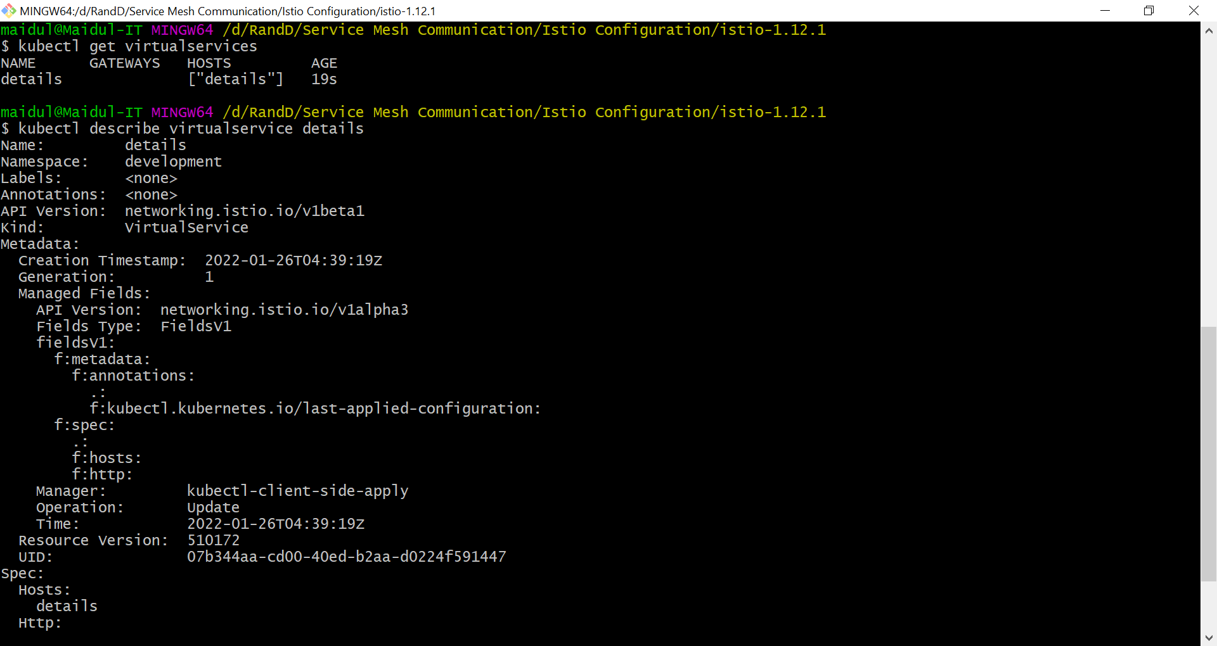

1. Browse to <http://localhost/productpage> (same functionality)

Book details are coming from microservice. They are now routed through the **virtualservice** configuration, but that configuration is just the same as the previous one, and everything works in the same way.

Now we are going to test with a bad service update.

## 1.1 Update virtual service with timeout

Now we are going to configure a virtual service to details section of the page times out after 5 seconds.

1. Create a yaml file **details-virtualservice-timeout.yaml** and write below code.

apiVersion: networking.istio.io/v1alpha3

kind: VirtualService

metadata:

  name: details

spec:

  hosts:

  - details

  http:

  - route:

    - destination:

        host: details

    timeout: 5s

1. Now execute **details-virtualservice-timeout.yaml** file with below command.

kubectl apply -f details-virtualservice-timeout.yaml

1. Browse to <http://localhost/productpage> - details call times out after 5 seconds

## 1.2 Update virtual service with retry

Now we are going to configure the virtual service to retry a service after timeout.

1. Create a YAMl file and name the file **details-virtualservice-retry.yaml** and write below code.

apiVersion: networking.istio.io/v1alpha3

kind: VirtualService

metadata:

  name: details

spec:

  hosts:

  - details

  http:

  - route:

    - destination:

        host: details

    retries:

      attempts: 2

      perTryTimeout: 5s

      retryOn: 5xx

1. Execute above file with below command.

kubectl apply -f details-virtualservice-retry.yaml

1. Browse to <http://localhost/productpage> - details call times out and then automatically retries

# Configuration of Dark Launch

Now we are going to configure a reviews service version and that version will be visible to **tester** user only, other user will see different version.

## 1.0 Pre-reqs

1. Reset kubernetes if you are using local environment or clear previously deployed services.
2. Re-Install and execute Istio and bookinfo app as we did earlier.

## 1.1 Deploy v2

Now we are going deploy new version of **reviews** file.

1. Create a YAML file **reviews-v2.yaml** and write below code.

apiVersion: apps/v1

kind: Deployment

metadata:

  name: reviews-v2

  labels:

    app: reviews

    version: v2

spec:

  replicas: 1

  selector:

    matchLabels:

      app: reviews

      version: v2

  template:

    metadata:

      labels:

        app: reviews

        version: v2

    spec:

      serviceAccountName: bookinfo-reviews

      containers:

        - name: reviews

          image: docker.io/istio/examples-bookinfo-reviews-v2:1.15.0

          imagePullPolicy: IfNotPresent

          ports:

            - containerPort: 9080

1. Execute below command.

kubectl apply -f reviews-v2.yaml

1. Now check the deployment with below commnd.

kubectl get po -l app=reviews

kubectl describe svc reviews

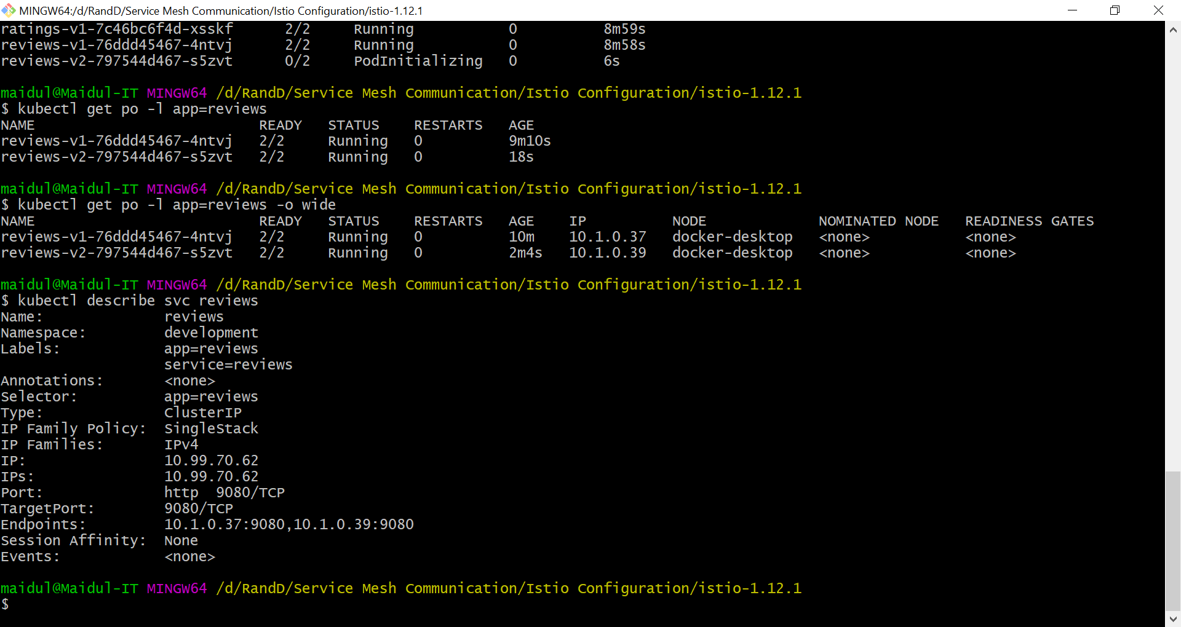

We can see that selector has **app=reviews** and service is using endpoint of both reviews versions, which means unless we shape the traffic using istio, it’s going to get load balance between Version and   
Version 2.

Browse to <http://localhost/productpage> and refresh, requests load-balanced between v1 and v2.  
You will see that reviews section is changing.

## 1.2 Switch to Dark Launch

Now we are going to configure dark launch with Istio so only my test users can see Version 2 component with the start rating.

We are going to define Destination Rule and Virtual Service of Istio.

1. Deploy test user routing rules. Create a YAML file and name the file **reviews-v2-tester.yaml**, write below code.

apiVersion: networking.istio.io/v1alpha3

kind: DestinationRule

metadata:

  name: reviews

spec:

  host: reviews

  trafficPolicy:

    tls:

      mode: ISTIO_MUTUAL

  subsets:

  - name: v1

    labels:

      version: v1

  - name: v2

    labels:

      version: v2

---

apiVersion: networking.istio.io/v1alpha3

kind: VirtualService

metadata:

  name: reviews

spec:

  hosts:

  - reviews

  http:

  - match:

    - headers:

        end-user:

          exact: tester

    route:

    - destination:

        host: reviews

        subset: v2

  - route:

    - destination:

        host: reviews

        subset: v1

1. Execute above code with below command and verify.

kubectl apply -f reviews-v2-tester.yaml  
  
kubectl get virtualservice  
  
kubectl describe vs reviews

Browse to <http://localhost/productpage> - all users see v1 except testuser who sees v2. As we can see that on browser, reviews section is not changing.

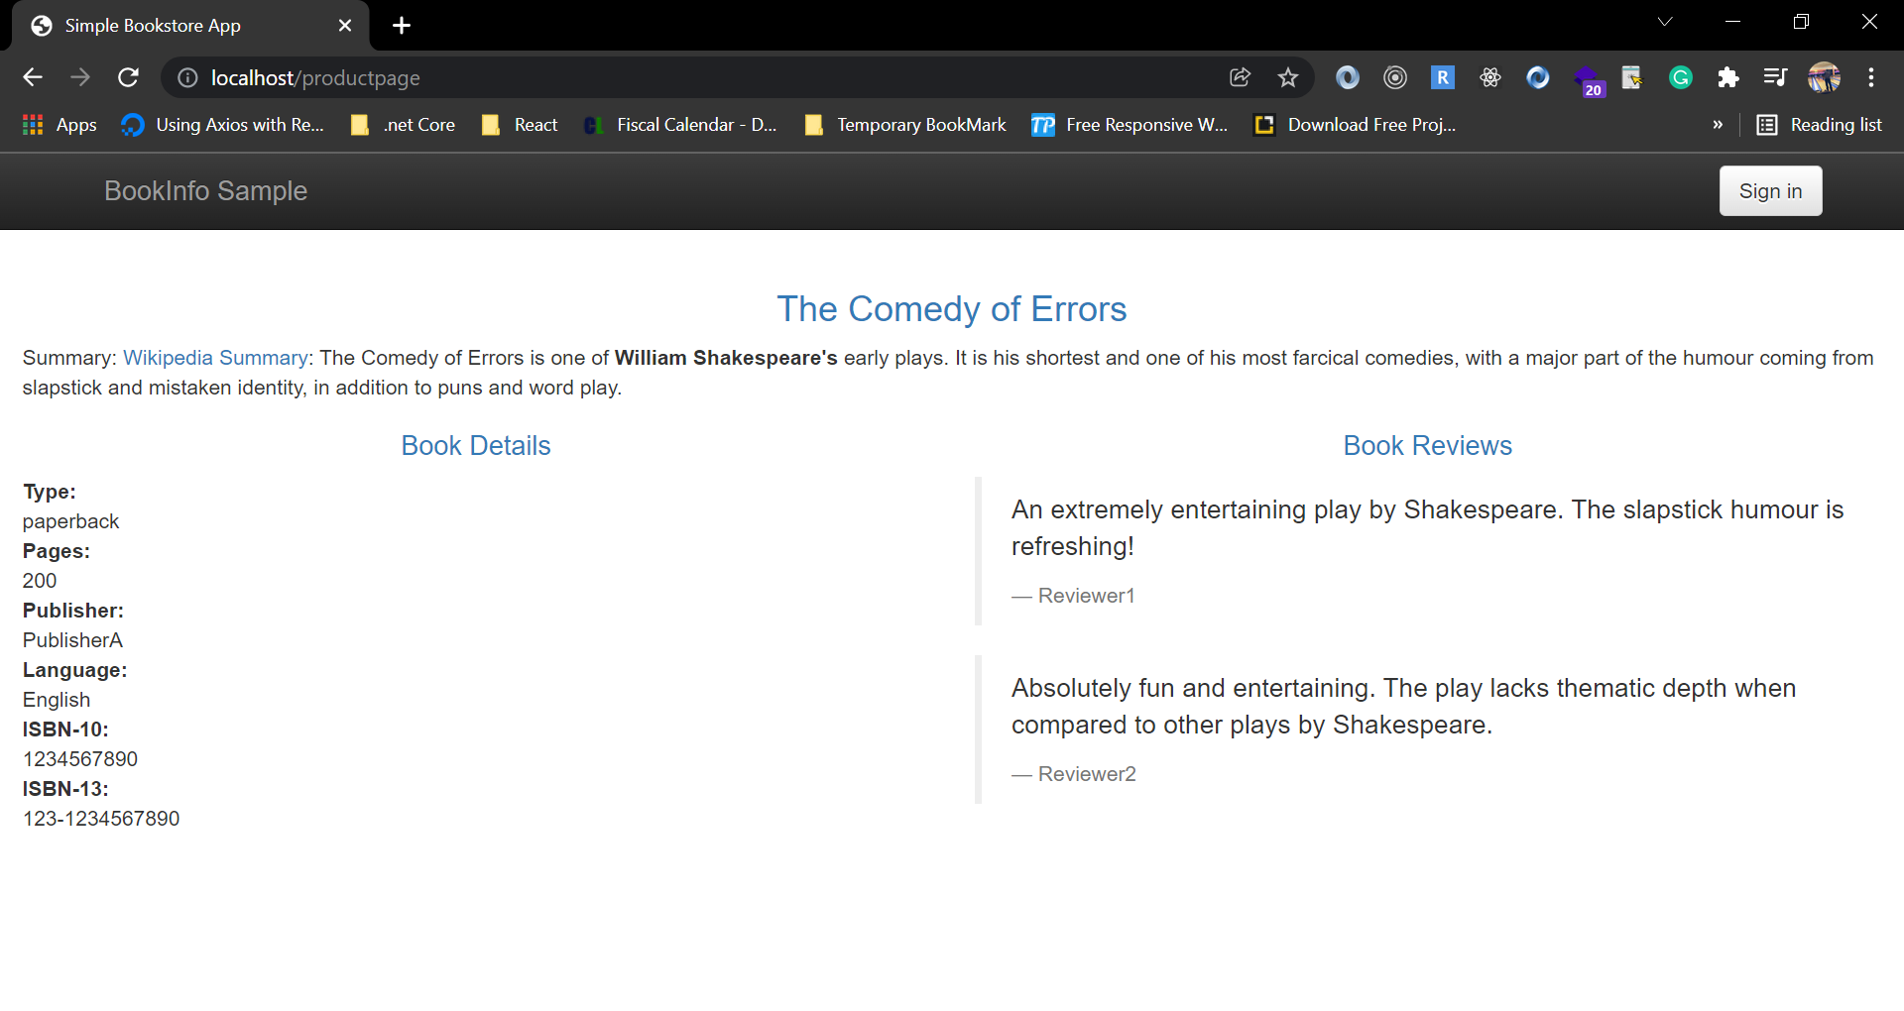

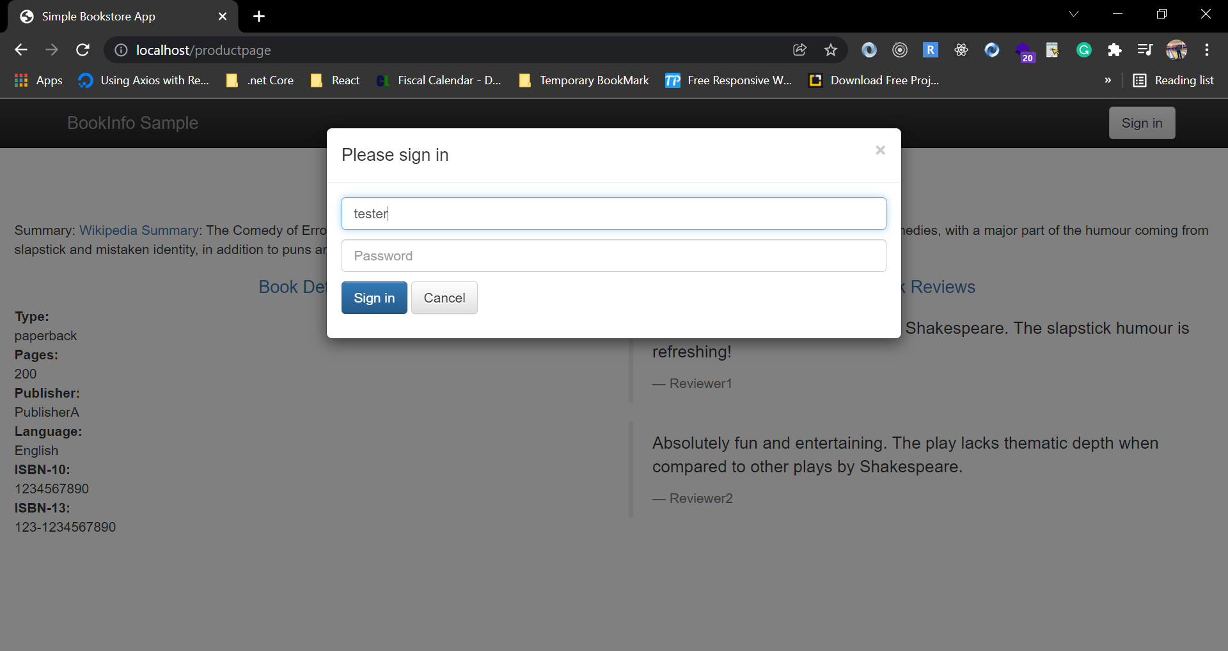

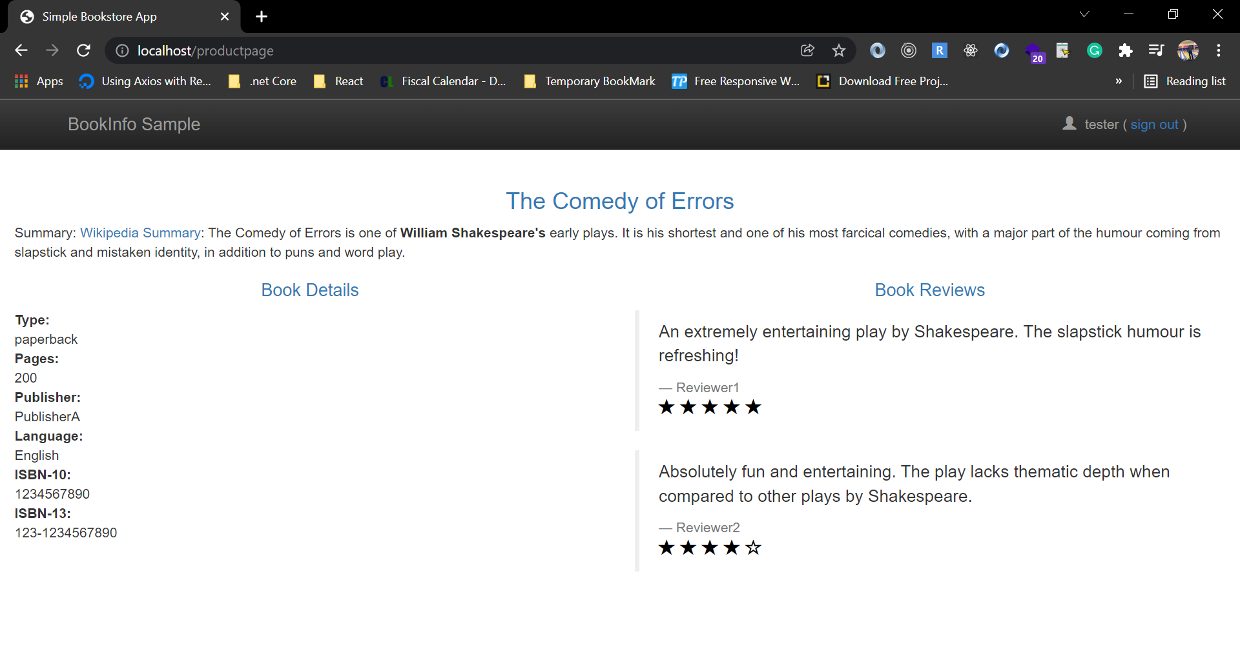

As we can see that after login as **tester,** reviews section is showing **v2.**

## 1.3 Test with Network Delay

Now we are going to configure reviews with network delay. We can define custom delay time which is helpful in microservice.

1. Create a VirtualService YAML file with network delay and name the file **reviews-v2-tester-delay.yaml** and write below code.

apiVersion: networking.istio.io/v1alpha3

kind: VirtualService

metadata:

  name: reviews

spec:

  hosts:

    - reviews

  http:

    - match:

        - headers:

            end-user:

              exact: tester

      fault:

        delay:

          percent: 100

          fixedDelay: 2.5s

      route:

        - destination:

            host: reviews

            subset: v2

    - route:

        - destination:

            host: reviews

            subset: v1

On the above code I have added 2.5s delay

1. Deploy delay test rules with below command.

kubectl apply -f reviews-v2-tester-delay.yaml

1. Browse to <http://localhost/productpage> - testuser gets delayed response, all others OK

You can see the loading time differences between in login as tester mode and without login. In login mode, page loading is taking 2.5s.

# Configuration of Blue/Green Deployment

In Blue/Green deployment, we can run two version of application. All version will be on different domain name and we can also configure test domain not to available for public.

In Blue/Green deployment Istio will give us a switch to flip between different version.

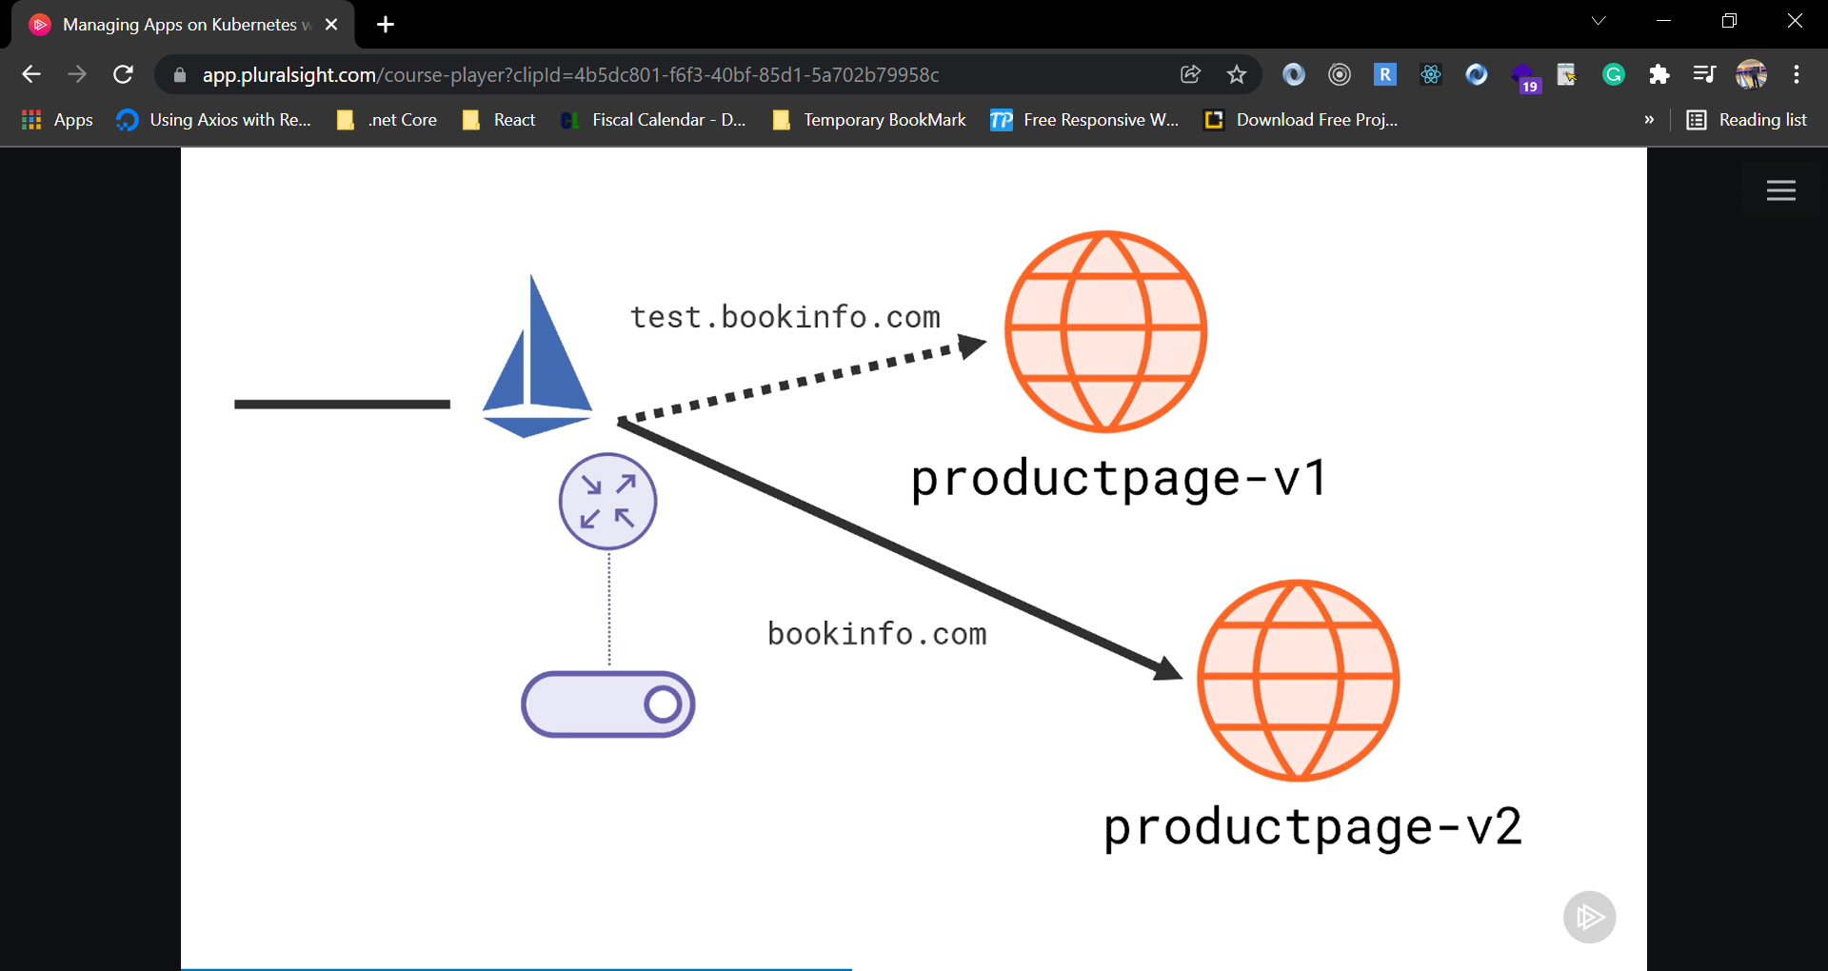

Launch a new version of the homepage, and switch the domain between live and test versions.

In our configuration has got a Destination Rule with two subsets setup that are picking pods based on the labels that they have applied but because this virtual service is listening for external traffic, it has the full domain name as the host. So external traffic that has coming into my cluster for the bookinfo.com site is going to served by v1 subset, and traffic will go to one of the pods that have version v1 label applied.

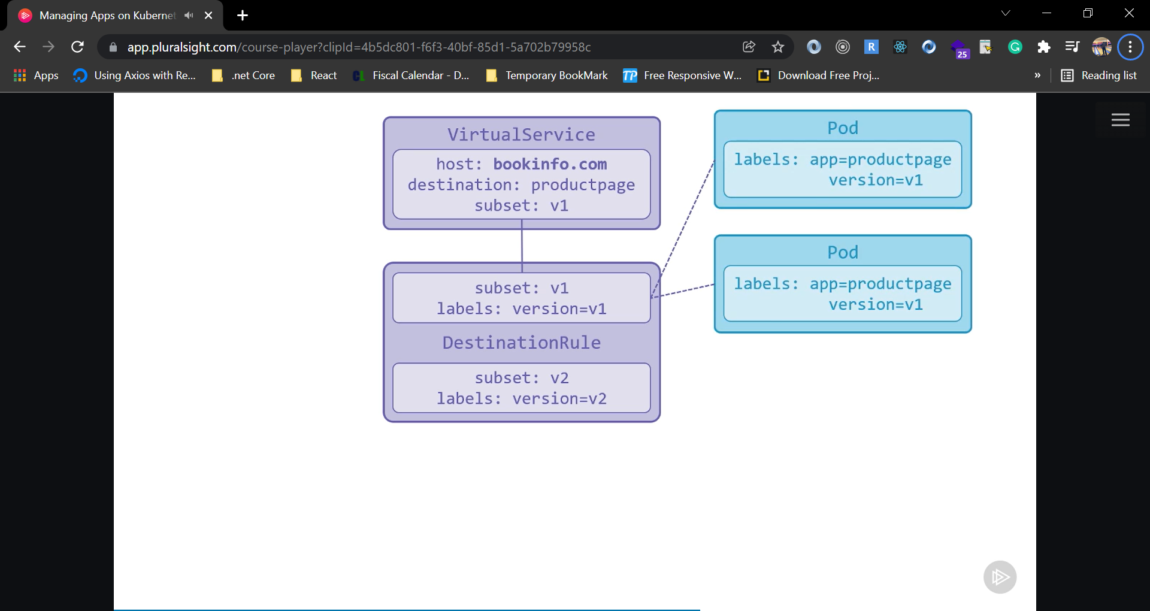

I have also separated virtual service with the host name text.bookinfo.com in the same cluster and that is using subset v2. So when traffic comes into the cluster, browsing to test.bookinfo.com, that traffic is going to get served by 1 of the v2 pods.

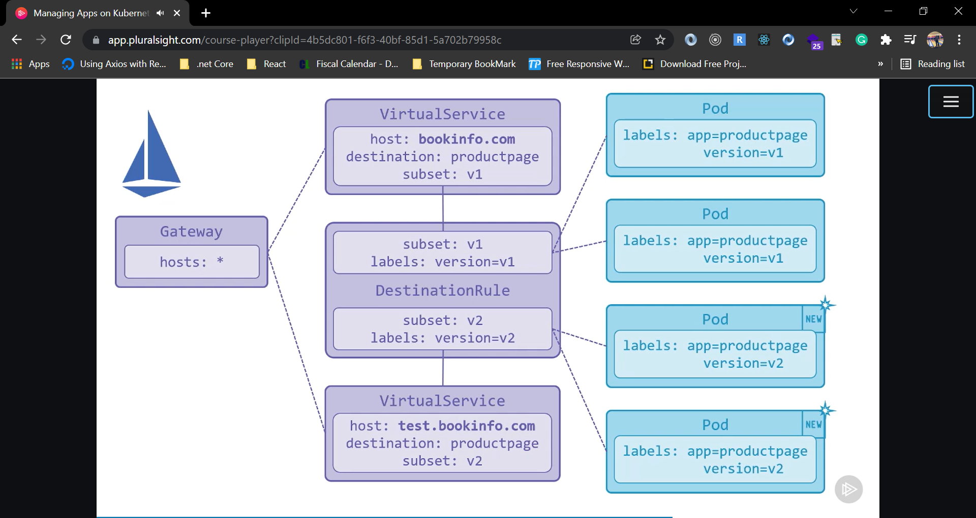

As it is external traffic, in order to have the Istio rules applied, we need to have a gateway listening for incoming requests, and we can have a Gateway that listens for traffic on any domain name, and depending on the request that comes in, it will direct it to one of the virtual services which will go through the subset and ultimately to one of my pods.

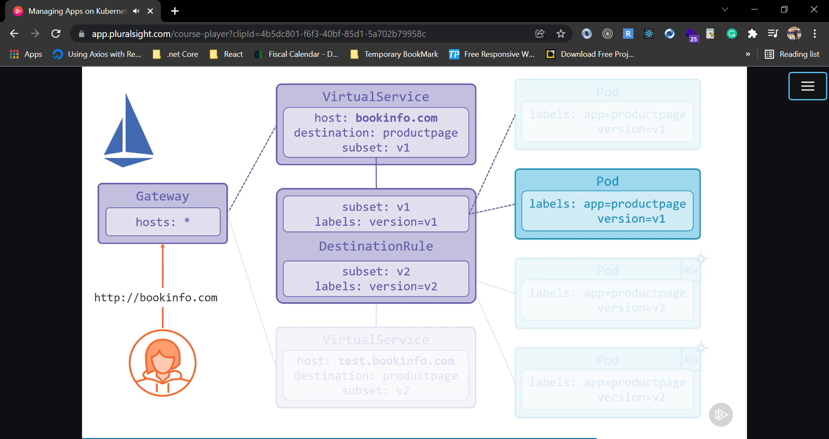

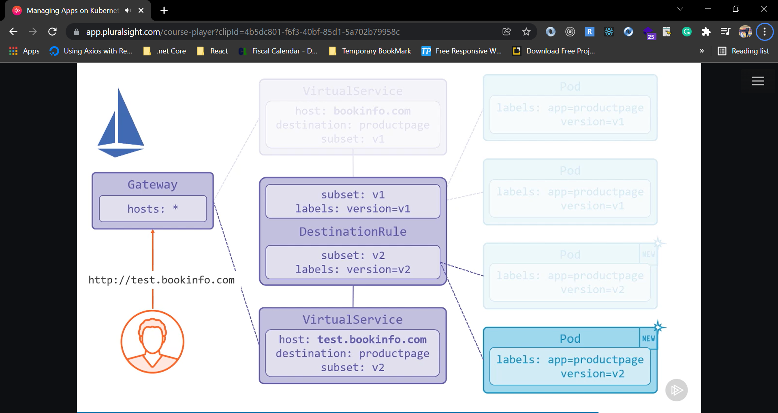

## 1.0 Pre-reqs

Deploy Istio & bookinfo like we did before.

## 1.1 Deploy v2

1. Using existing gateway:

kubectl describe gateway bookinfo-gateway

As we have planned to deploy two different versions of prodcutPage. Both version of prorudctPage will be routed through same gateway.

Now we are going to Deploy v2 product page with test domain.

1. Create a file and name the file ***productpage-v2.yaml*** and write below code.

apiVersion: apps/v1

kind: Deployment

metadata:

  name: productpage-v2

  labels:

    app: productpage

    version: v2

spec:

  replicas: 1

  selector:

    matchLabels:

      app: productpage

      version: v2

  template:

    metadata:

      labels:

        app: productpage

        version: v2

    spec:

      serviceAccountName: bookinfo-productpage

      containers:

        - name: productpage

          image: docker.io/sixeyed/bookinfo-productpage:v2

          imagePullPolicy: IfNotPresent

          ports:

            - containerPort: 9080

---

apiVersion: networking.istio.io/v1alpha3

kind: DestinationRule

metadata:

  name: productpage

spec:

  host: productpage

  trafficPolicy:

    tls:

      mode: ISTIO_MUTUAL

  subsets:

    - name: v1

      labels:

        version: v1

    - name: v2

      labels:

        version: v2

---

apiVersion: networking.istio.io/v1alpha3

kind: VirtualService

metadata:

  name: bookinfo

spec:

  hosts:

    - bookinfo.local

  gateways:

    - bookinfo-gateway

  http:

    - route:

        - destination:

            host: productpage

            subset: v1

            port:

              number: 9080

---

apiVersion: networking.istio.io/v1alpha3

kind: VirtualService

metadata:

  name: bookinfo-test

spec:

  hosts:

    - test.bookinfo.local

  gateways:

    - bookinfo-gateway

  http:

    - route:

        - destination:

            host: productpage

            subset: v2

            port:

              number: 9080

1. Now execute the above file with below command.

kubectl apply -f productpage-v2.yaml

1. Check deployment:

kubectl get pods -l app=productpage

kubectl describe vs bookinfo

kubectl describe vs bookinfo-test

1. Add bookinfo.local domains to hosts file:

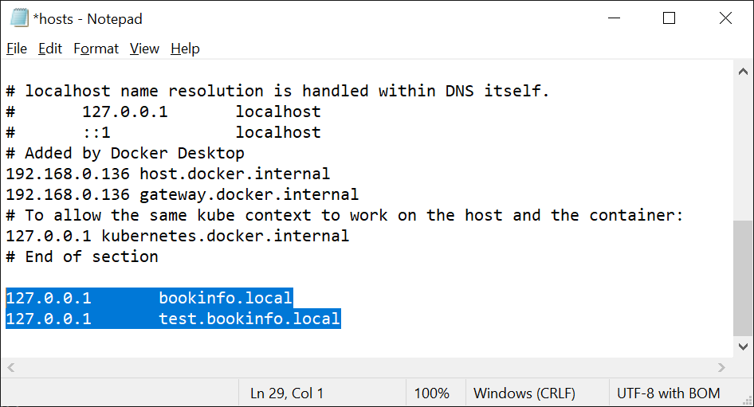

cat C:\Windows\System32\drivers\etc\hosts

# on Linux or Mac add to `/etc/hosts`

Browse to live v1 set at <http://bookinfo.local/productpage>

Browse to test v2 site at <http://test.bookinfo.local/productpage>

## 1.2 Blue/Green deployment – Flip

Now we are going to flip the virtual services from v1 to v2 and v2 to v1.

1. Create a YAMl file and name it **productpage-test-to-live.yaml** and write below code**.**

apiVersion: networking.istio.io/v1alpha3

kind: VirtualService

metadata:

  name: bookinfo

spec:

  hosts:

    - bookinfo.local

  gateways:

    - bookinfo-gateway

  http:

  - route:

    - destination:

        host: productpage

        subset: v2

        port:

          number: 9080

---

apiVersion: networking.istio.io/v1alpha3

kind: VirtualService

metadata:

  name: bookinfo-test

spec:

  hosts:

    - test.bookinfo.local

  gateways:

    - bookinfo-gateway

  http:

  - route:

    - destination:

        host: productpage

        subset: v1

        port:

          number: 9080

1. Now execute the file with below command.

kubectl apply -f productpage-test-to-live.yaml

1. Check live deployment:

kubectl describe vs bookinfo

1. Now test on browser. Live is now v2 at <http://bookinfo.local/productpage>
2. Check test deployment:

kubectl describe vs bookinfo-test

Test is now v1 at <http://test.bookinfo.local/productpage>

## 1.3 Blue/green deployment - flip back

Now we are going to flip the deployment - live to test switch.

1. Create a YAMl file and name it **productpage-live-to-test.yaml** and write below code**.**

apiVersion: networking.istio.io/v1alpha3

kind: VirtualService

metadata:

  name: bookinfo

spec:

  hosts:

    - bookinfo.local

  gateways:

    - bookinfo-gateway

  http:

  - route:

    - destination:

        host: productpage

        subset: v1

        port:

          number: 9080

---

apiVersion: networking.istio.io/v1alpha3

kind: VirtualService

metadata:

  name: bookinfo-test

spec:

  hosts:

    - test.bookinfo.local

  gateways:

    - bookinfo-gateway

  http:

  - route:

    - destination:

        host: productpage

        subset: v2

        port:

          number: 9080

1. Deploy live to test switch

kubectl apply -f productpage-live-to-test.yaml

Live is back to v1 <http://bookinfo.local/productpage>

Test is back to v2 <http://test.bookinfo.local/productpage>

# Configuring Canary Deployment

We can run multiple version of application live with canary deployment, and can be use Istio to configure how much traffic goes to each versions. This process lets to gradual stage rollout.

We can distribute the traffic between different deployment or pod with canery deployment.

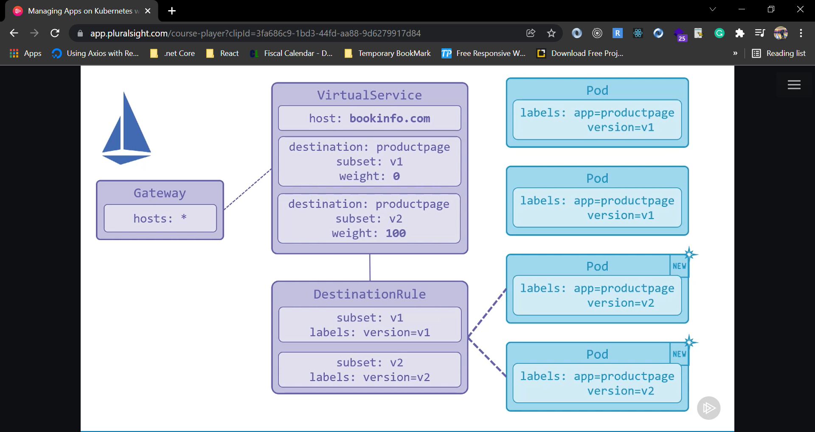

## 1.0 Canary deployment with 30% traffic to v2

We are going to change on virtual service for canary deployment. We are going to send 70% of traffic to V1 subset and 30% to V2 subset.

1. Create a YAMl file and name it **productpage-canary-70-30.yaml** and write below code**.**

apiVersion: networking.istio.io/v1alpha3

kind: VirtualService

metadata:

  name: bookinfo

spec:

  hosts:

    - bookinfo.local

  gateways:

    - bookinfo-gateway

  http:

  - route:

    - destination:

        host: productpage

        subset: v1

        port:

          number: 9080

      weight: 70

    - destination:

        host: productpage

        subset: v2

        port:

          number: 9080

      weight: 30

1. Now execute the command.

kubectl apply -f productpage-canary-70-30.yaml

1. Now Check deployment with below command.

kubectl describe vs bookinfo-test

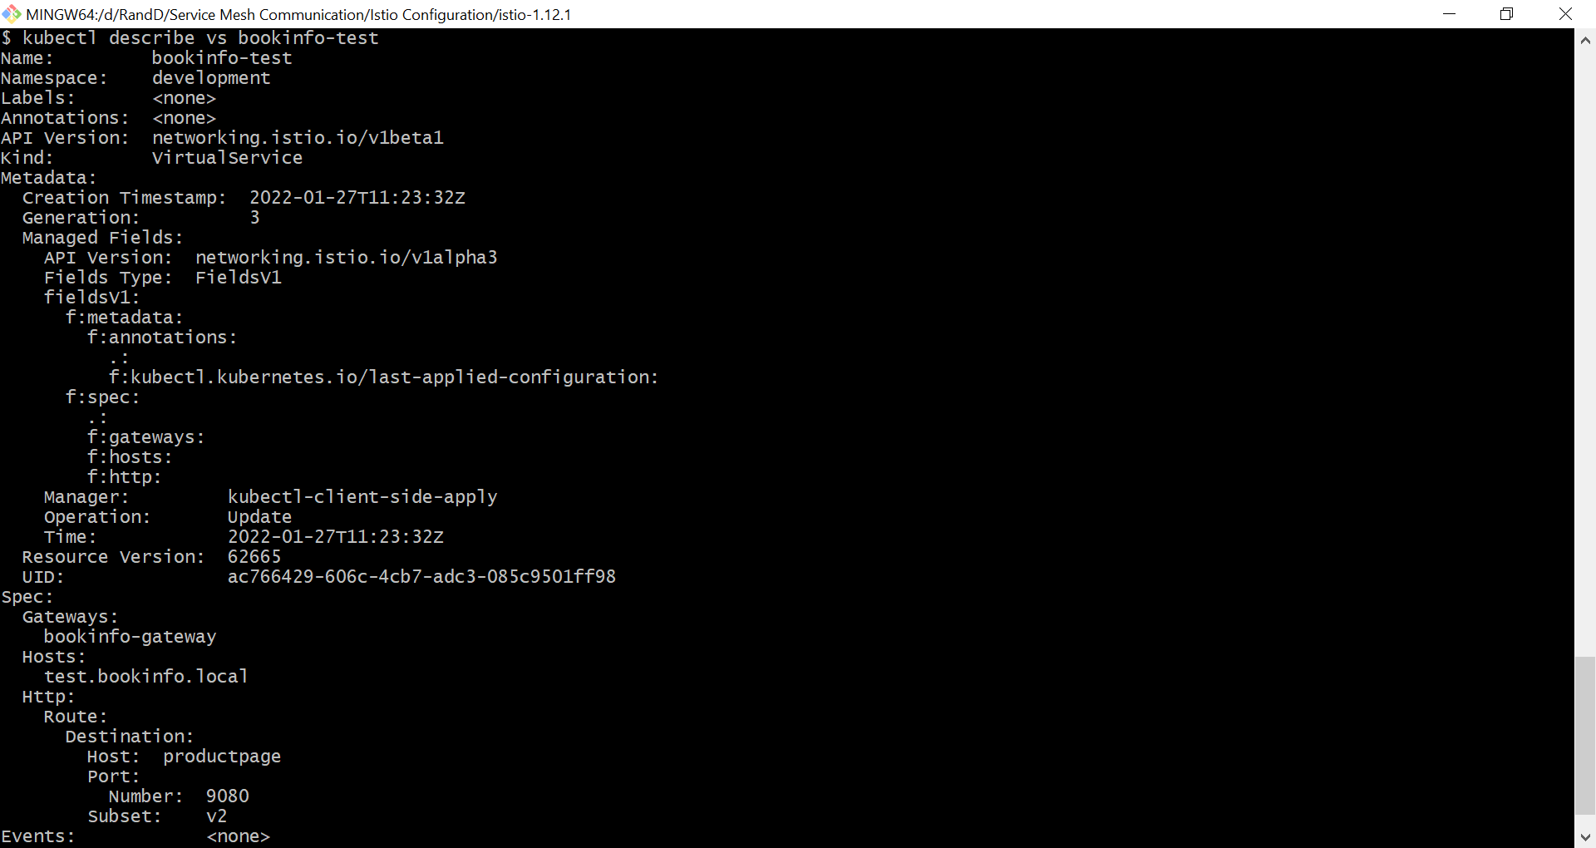

kubectl describe vs bookinfo

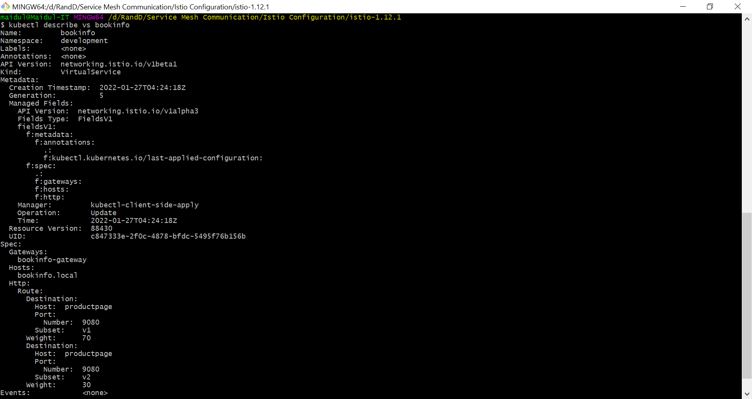

1. Now Browse to <http://bookinfo.local/productpage> & refresh, mostly v1 responses with some v2.

## 1.1 Canary Rollout

We can slowly change the traffic by changing the percentage as above. We cab Shift traffic to v2 like below.

* 55/45 split
* 25/75 split
* 0/100 split

### 55/45 split

apiVersion: networking.istio.io/v1alpha3

kind: VirtualService

metadata:

  name: bookinfo

spec:

  hosts:

    - bookinfo.local

  gateways:

    - bookinfo-gateway

  http:

  - route:

    - destination:

        host: productpage

        subset: v1

        port:

          number: 9080

      weight: 55

    - destination:

        host: productpage

        subset: v2

        port:

          number: 9080

      weight: 45

### 25/75 split

apiVersion: networking.istio.io/v1alpha3

kind: VirtualService

metadata:

  name: bookinfo

spec:

  hosts:

    - bookinfo.local

  gateways:

    - bookinfo-gateway

  http:

  - route:

    - destination:

        host: productpage

        subset: v1

        port:

          number: 9080

      weight: 25

    - destination:

        host: productpage

        subset: v2

        port:

          number: 9080

      weight: 75

### 0/100 split

apiVersion: networking.istio.io/v1alpha3

kind: VirtualService

metadata:

  name: bookinfo

spec:

  hosts:

    - bookinfo.local

  gateways:

    - bookinfo-gateway

  http:

  - route:

    - destination:

        host: productpage

        subset: v1

        port:

          number: 9080

      weight: 0

    - destination:

        host: productpage

        subset: v2

        port:

          number: 9080

      weight: 100

## 1.2 Canary with Sticky Session

As we can see that with the above configuration, two versions are changing at the same browser which will not give good user experience. We need to configure to deploy specific version of the application on a browser, in that case some user will see V1 and some user will see V2.

We can set on cookie the exact version browser going to experience, so the browser will not rollout between V1 and V2.

1. Create a YAMl file and name it **productpage-canary-with-cookie.yaml** and write below code.

apiVersion: networking.istio.io/v1alpha3

kind: VirtualService

metadata:

  name: bookinfo

spec:

  hosts:

    - bookinfo.local

  gateways:

    - bookinfo-gateway

  http:

    - match:

        - headers:

            cookie:

              regex: "^(.*?;)?(product-page=v2)(;.*)?$"

      route:

        - destination:

            host: productpage

            subset: v2

            port:

              number: 9080

    - route:

        - destination:

            host: productpage

            subset: v1

            port:

              number: 9080

          weight: 70

        - destination:

            host: productpage

            subset: v2

            port:

              number: 9080

          weight: 30

1. Now execute the file with below command.

kubectl apply -f productpage-canary-with-cookie.yaml

1. Browse to <http://bookinfo.local/productpage> & refresh - once you hit v2 that puts a cookie in your browser, and you'll always get v2.
2. You can also test by disabling cookies.

# Configuration of Circuit Breaker

In Kubernetes, application can be run on multiple pods and Istio going to load balance request between those pods. Now if the application starts to fail in one of those pods, by Istio going to keep sending the traffic to it and it will keep getting errors.

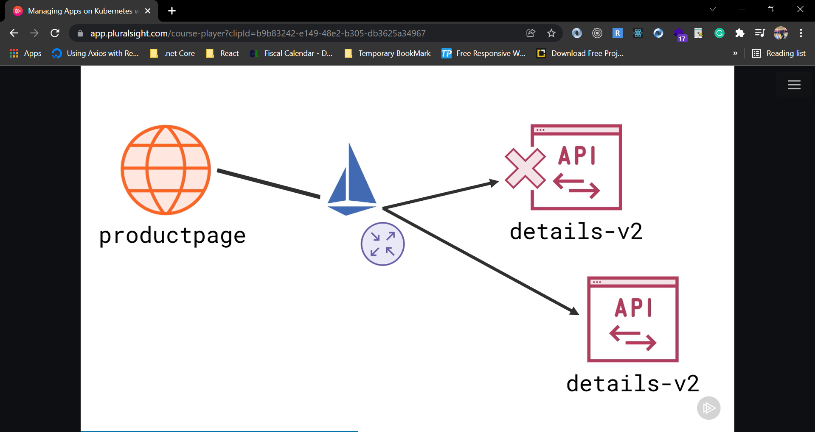

Second part of the problem is, if we configured Istio to automatically retry when it gets errors, then we are going to end up sending even more traffic to this failing component, and that can amplify the problem.

Istio lets us fix this using Circuit Breaker pattern, it is monitors the behavior of all of the instances that are in that load balanced group, and if one of them starts to fail, it takes it out of the group.

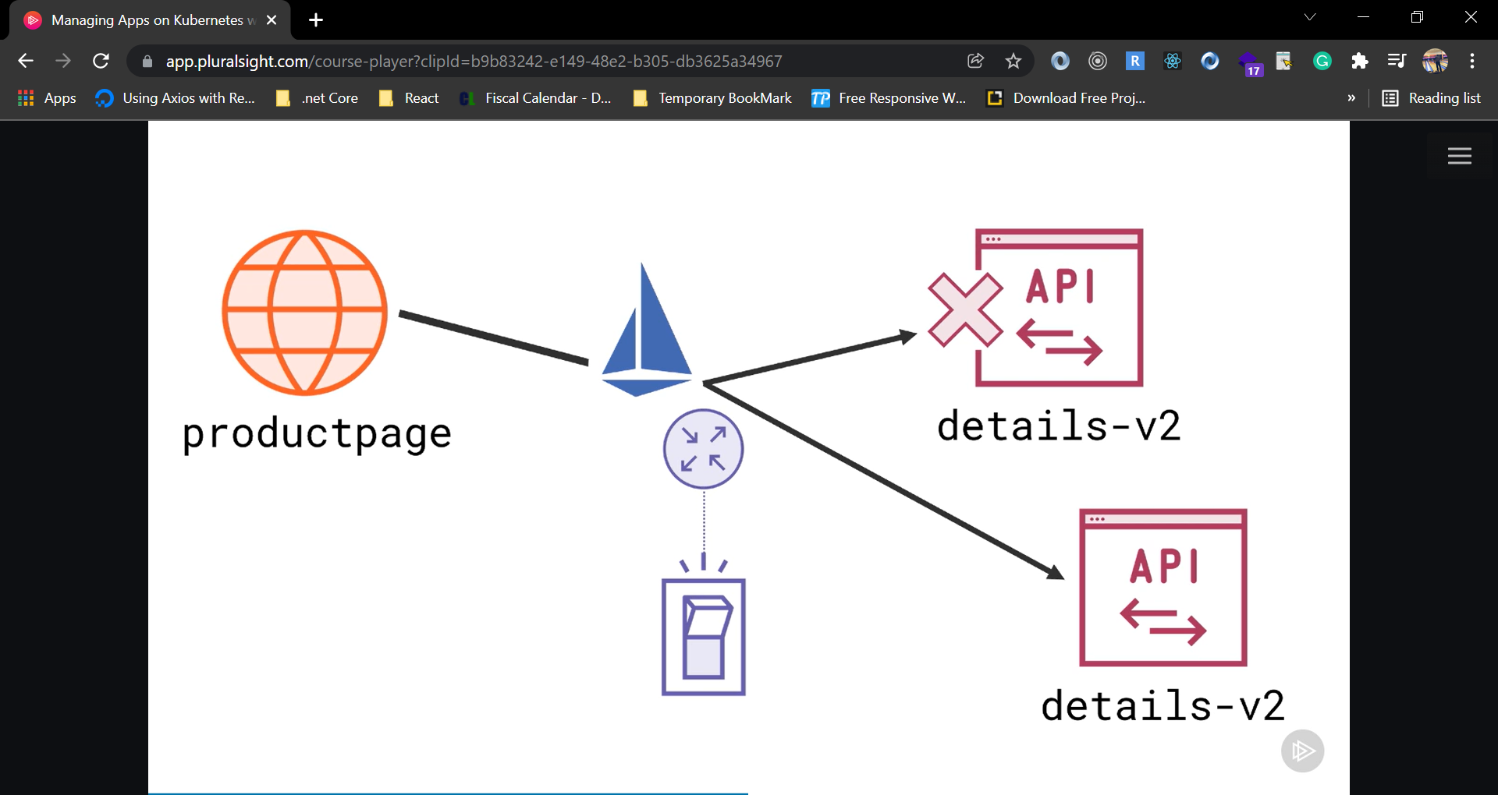 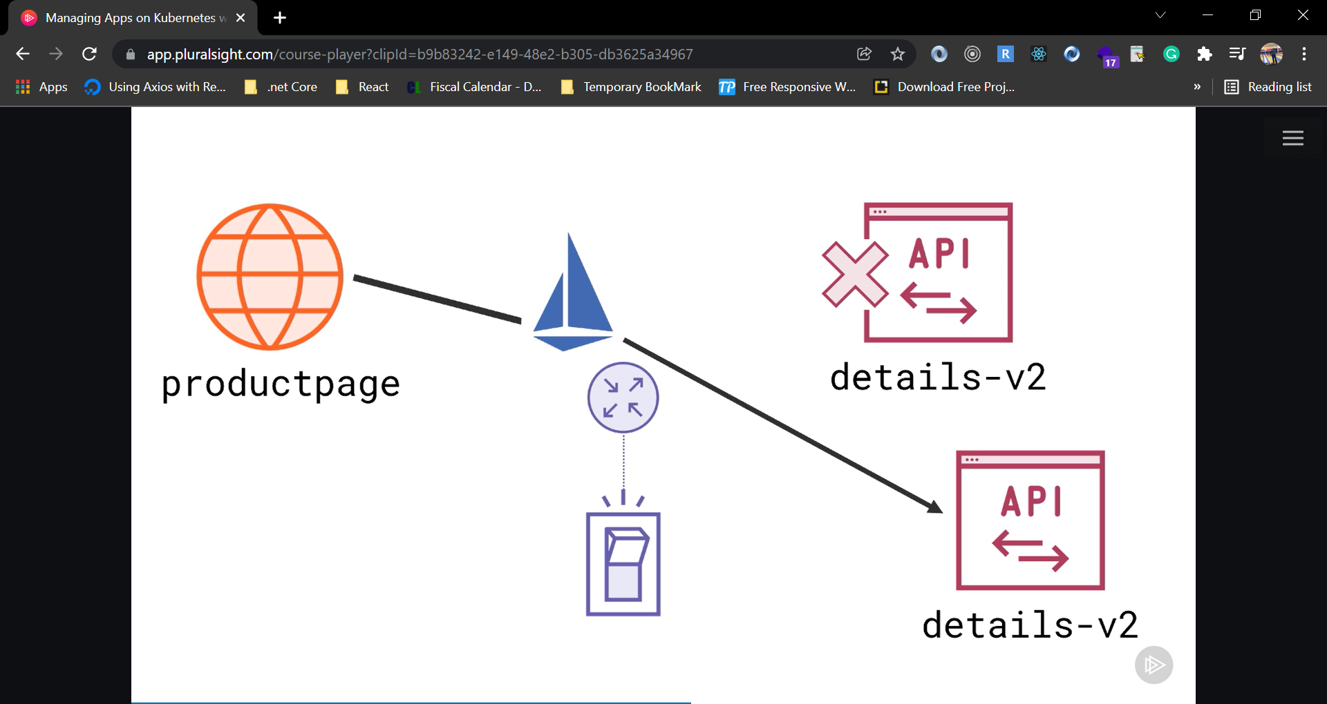

As we can see it is a traffic management scenario, we can use Isio Virtual Service and Destination Rule.

*** Add outlier detection to a load-balanced servcie so unhealthy endpoints are removed.

## 1.0 Pre-reqs

Deploy Istio & bookinfo like we did before.

## 1.1 V2 Details Service

1. Now we are going to Deploy service update with 4 replicas. Create a YAMl file and name it **details-v2.yaml** and write below code.

apiVersion: apps/v1

kind: Deployment

metadata:

  name: details-v2

  labels:

    app: details

    version: v2

spec:

  replicas: 4

  selector:

    matchLabels:

      app: details

      version: v2

  template:

    metadata:

      labels:

        app: details

        version: v2

    spec:

      serviceAccountName: bookinfo-details

      containers:

        - name: details

          image: docker.io/sixeyed/bookinfo-details:v2

          imagePullPolicy: IfNotPresent

          ports:

            - containerPort: 9080

          env:

            - name: SERVICE_VERSION

              value: v-50-50-unhealthy

---

apiVersion: networking.istio.io/v1alpha3

kind: DestinationRule

metadata:

  name: details

spec:

  host: details

  trafficPolicy:

    tls:

      mode: ISTIO_MUTUAL

  subsets:

    - name: v1

      labels:

        version: v1

    - name: v2

      labels:

        version: v2

---

apiVersion: networking.istio.io/v1alpha3

kind: VirtualService

metadata:

  name: details

spec:

  hosts:

    - details

  http:

    - route:

        - destination:

            host: details

            subset: v2

1. Execute the above code with below command.

kubectl apply -f details-v2.yaml

1. Now Check deployment with below commands.

kubectl describe service details

kubectl describe vs details

kubectl describe dr details

1. Now Browse to <http://localhost/productpage> & refresh lots. Around 50% of details call fail.



1. We can check logs with below command.

kubectl logs -l app=details,version=v2 -c details

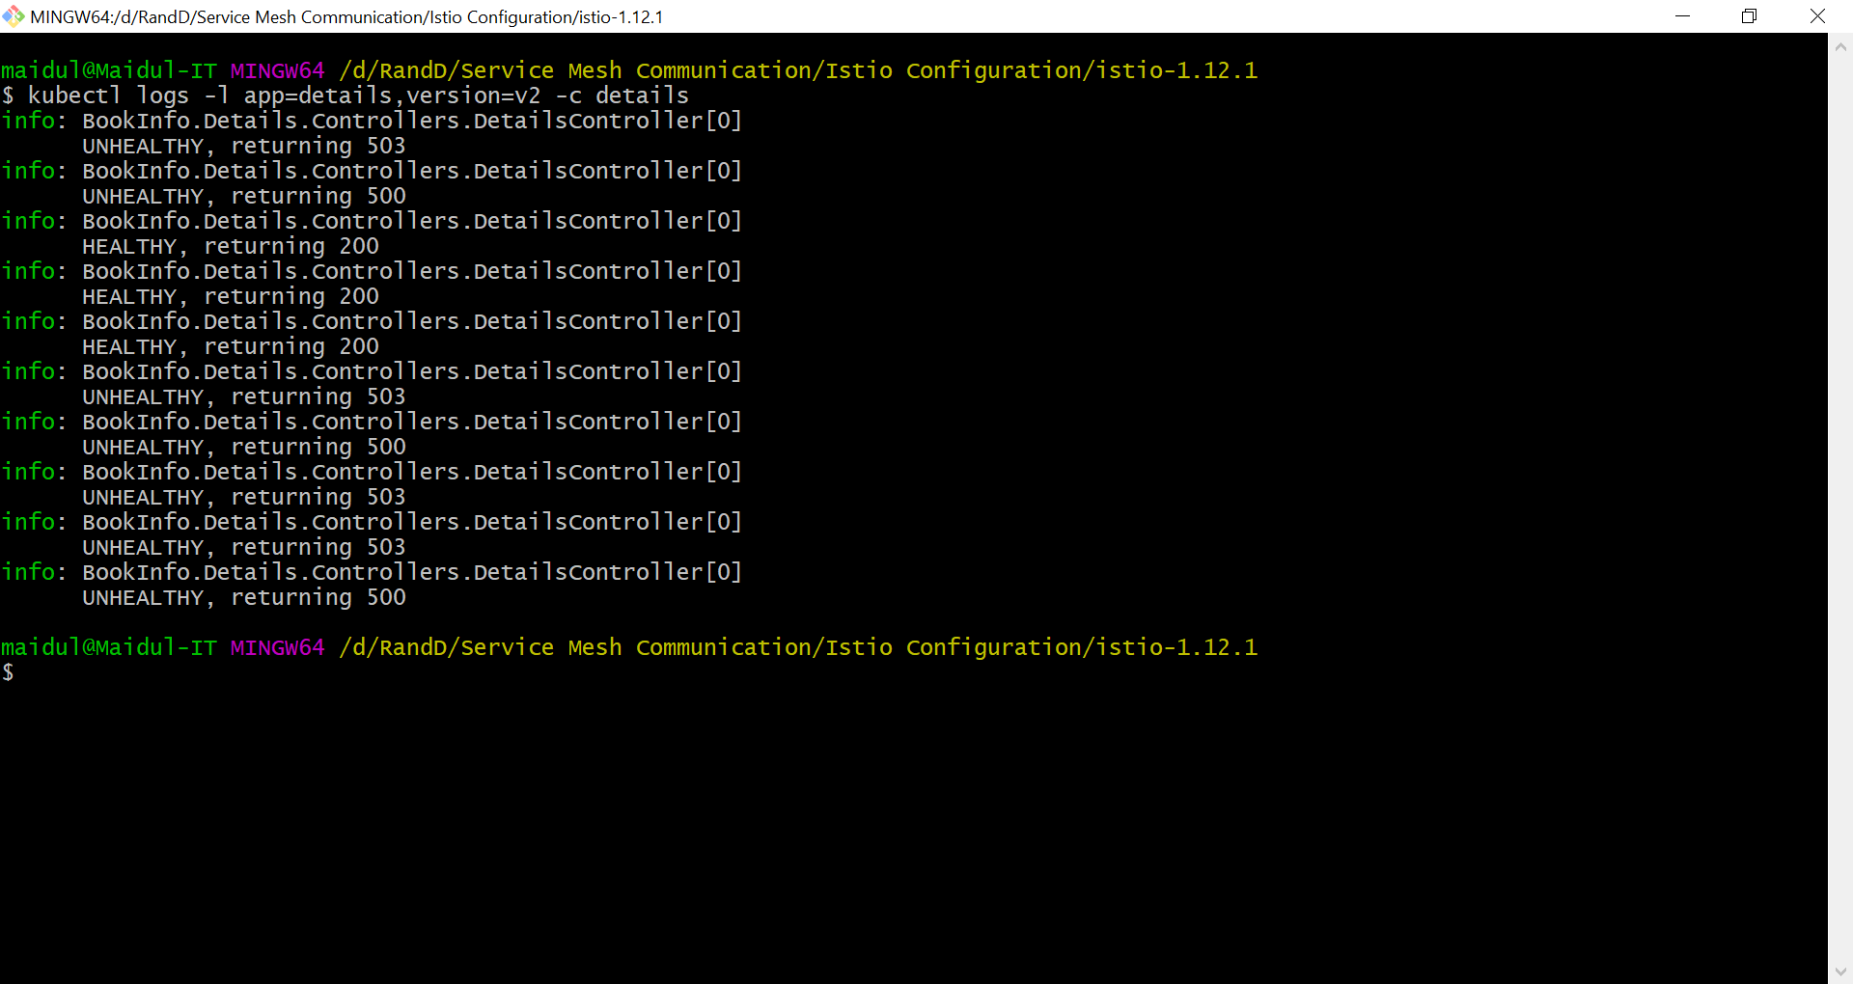

We can see that some are unhealthy and some are healthy.

## 1.2 Apply Circuit Breaker

As we have seen that if any of the pod goes down and if the client or browser point to that pod, it show error till refresh. We can resolve this issue by implementing circuit breaker with yaml file. In our YAML file we are going to define that if any error occurs consecutively for two times, automatically unhealthy pod will be out from the group.

Now we are going to Deploy updated rules with outlier detection:.

1. Create a YAML file and name the file **details-circuit-breaker.yaml** and write below code.

apiVersion: networking.istio.io/v1alpha3

kind: DestinationRule

metadata:

  name: details

spec:

  host: details

  trafficPolicy:

    tls:

      mode: ISTIO_MUTUAL

  subsets:

    - name: v1

      labels:

        version: v1

    - name: v2

      labels:

        version: v2

      trafficPolicy:

        outlierDetection:

          consecutiveErrors: 2

          interval: 1m

          baseEjectionTime: 5m

          maxEjectionPercent: 100

1. Execute the above code with below command.

kubectl apply -f details-circuit-breaker.yaml

1. Now check the deployment with below command.

kubectl describe dr details

1. Browse to <http://localhost/productpage> & refresh lots. As pods return errors they get excluded - after a while there are no errors, requests only go to healthy pods.

# Visualizing the Service Mesh

## Telemetry flow through Istio

We have already seen that Istio stays in the center of an application network and let’s user control the network traffic. We have used Istio to managed the destination of traffic and upgrade http to https.

Now we are going to configure another big feature of Istio and that is observility. Istio uses plugin model for this and it classifies telemetry into different types:

**Metrics** – which are things like the count of the number of requests and the count of the responses that come back.

**TraceSpan** – which is the entire span of the request, including child request that the component makes.

**LogEntry** – which are low level log that coming from proxies.

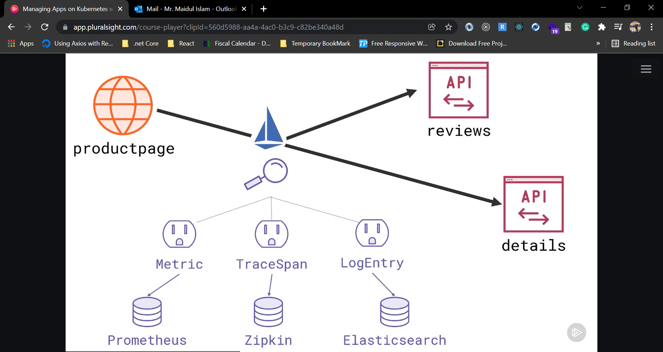

Above telemetry types can use different adapters to send the data to different back ends, and Istio ships with adapters for all industry standard software.

We can send metrics to Prometheus, Tracespans to Zipkins and logs to Elasticsearch.

Once you have all your telemetry data captured in the backends, it is possible to visualize through different frontends. Istio has support all the leading visualization software, most of are open source project.

Prometheus can power Kiali, which is frontend to visualize service mesh and see where the traffic is flowing. And Prometheus also support Grafana, which is generic frontend for dashboard but Istio ships with its own set of dashboard for monitoring Istio components and the services in the mesh.

Zipkin has its own UI for visualizing traces, but also integrated with Jaeger, which is a good frontend for breaking down your end user requests and visualizing all the service request that went into that one user request.

Elasticsearch has its own UI called Kibana, which is excellent for visualizing log entries and aggregating data.

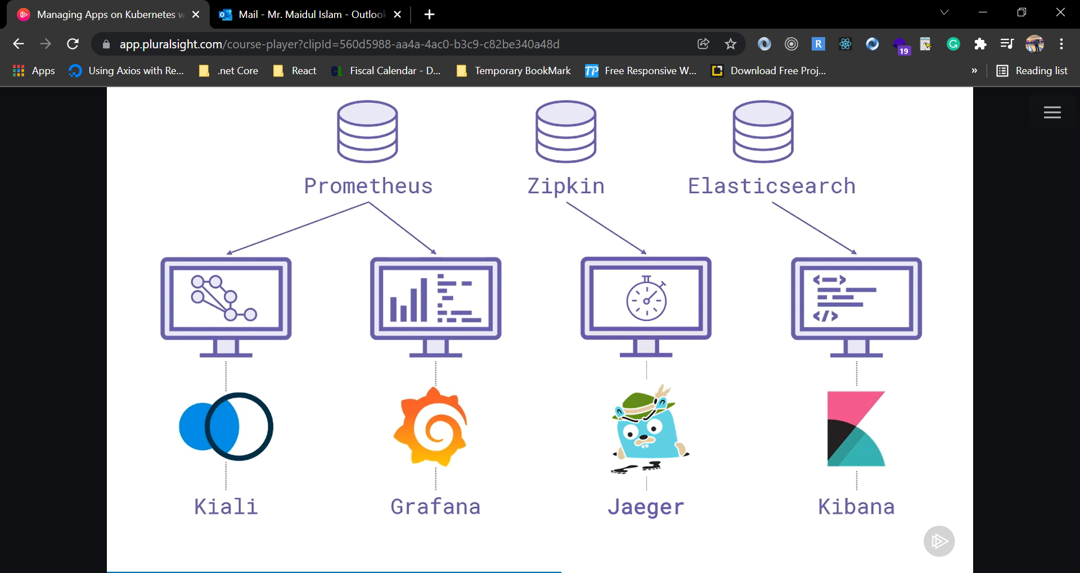

In our application, product page is consuming services from the reviews component and detail components and they are all registered with the service mesh, so all that communication is really going through the Istio proxies.

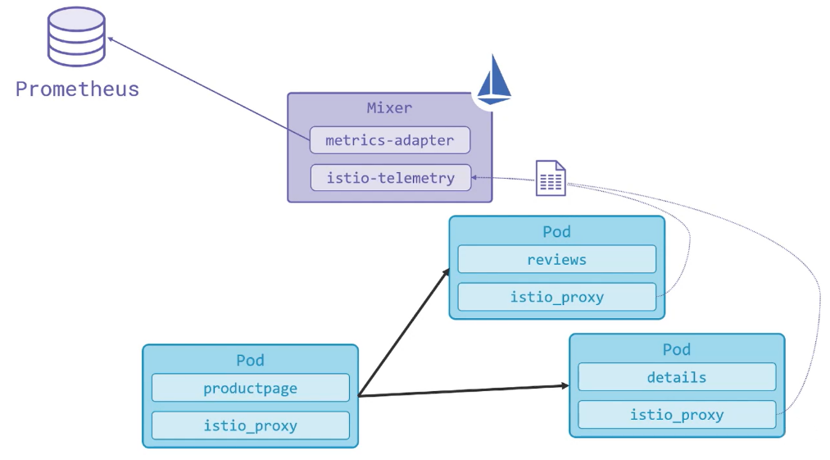

Now, when Istio is configured to collect telemetry, that happens in the component called mixer. Mixer is a Istio component which is part of the control plane, and one of its role is to collect telemetry report from the proxies with details about the requests they received and the response they have sent.

Mixer ingests the data from those reports and send it out to whichever backend is configured.

## Pre-reqs

Deploy Istio & bookinfo app as we did earlier.

## 1.1 View the Dashboard

Use the following instructions to deploy the Kiali dashboard, along with Prometheus, Grafana, and Jaeger.

1. Install Kiali and the other addons and wait for them to be deployed. Execute below command inside Istio folder.

kubectl apply -f samples/addons

1. Execute below command and wait till get success roll out message.

kubectl rollout status deployment/kiali -n istio-system

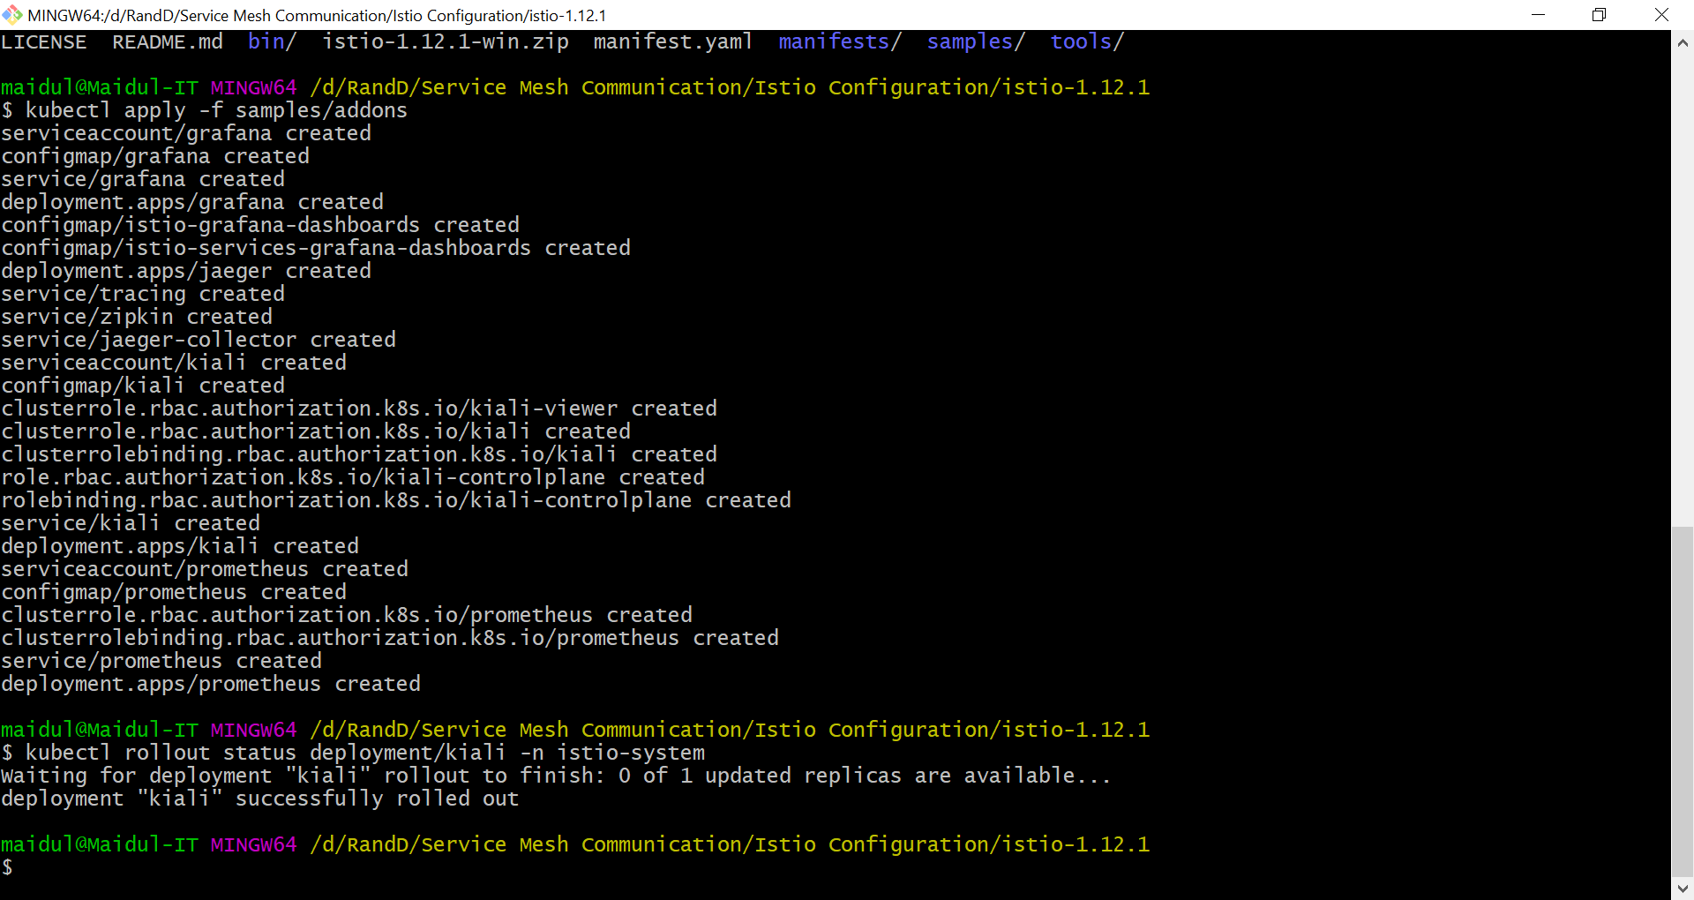

***If there are errors trying to install the addons, try running the command again. There may be some timing issues which will be resolved when the command is run again***

1. Verify the deployment with below command.

kubectl get po -n istio-system

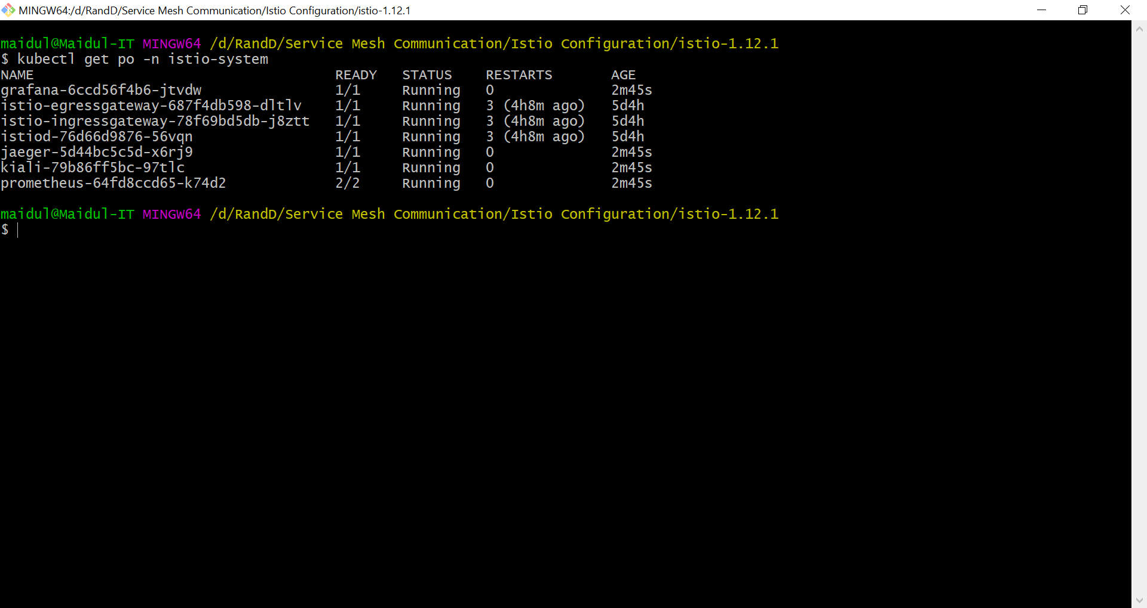

## 1.2 Publish the Kiali UI

Now we are going to Deploy a Gateway and VirtualService for Kiali.

1. Create a YAML file to define Gateway and Virtual Service for kiali. Name the file **kiali.yaml** and write below code.

apiVersion: networking.istio.io/v1alpha3

kind: Gateway

metadata:

  name: kiali-gateway

  namespace: istio-system

spec:

  selector:

    istio: ingressgateway

  servers:

  - port:

      number: 15029

      name: http-kiali

      protocol: HTTP

    hosts:

    - "*"

---

apiVersion: networking.istio.io/v1alpha3

kind: VirtualService

metadata:

  name: kiali-vs

  namespace: istio-system

spec:

  hosts:

  - "*"

  gateways:

  - kiali-gateway

  http:

  - match:

    - port: 15029

    route:

    - destination:

        host: kiali

        port:

          number: 20001

1. Execute above code with below command.

kubectl apply -f kiali.yaml

1. Browse to <http://localhost:15029>, sign in with admin/admin.
2. Or you can run with default kiali port with below command.

istioctl dashboard kiali

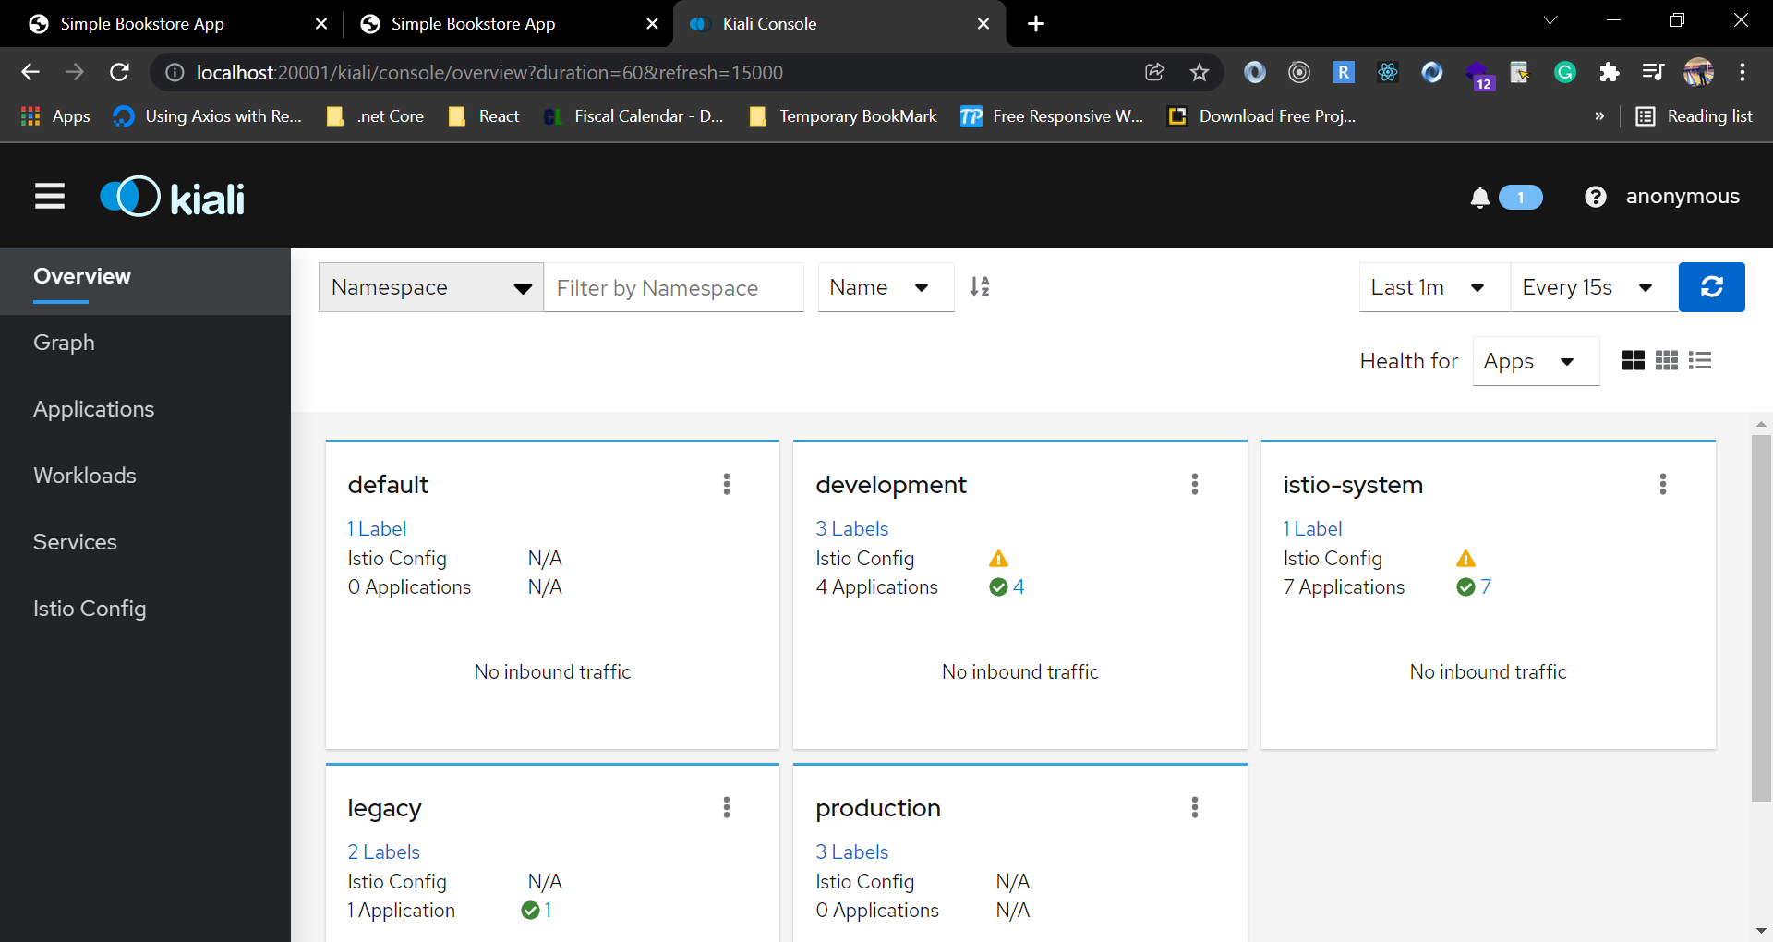

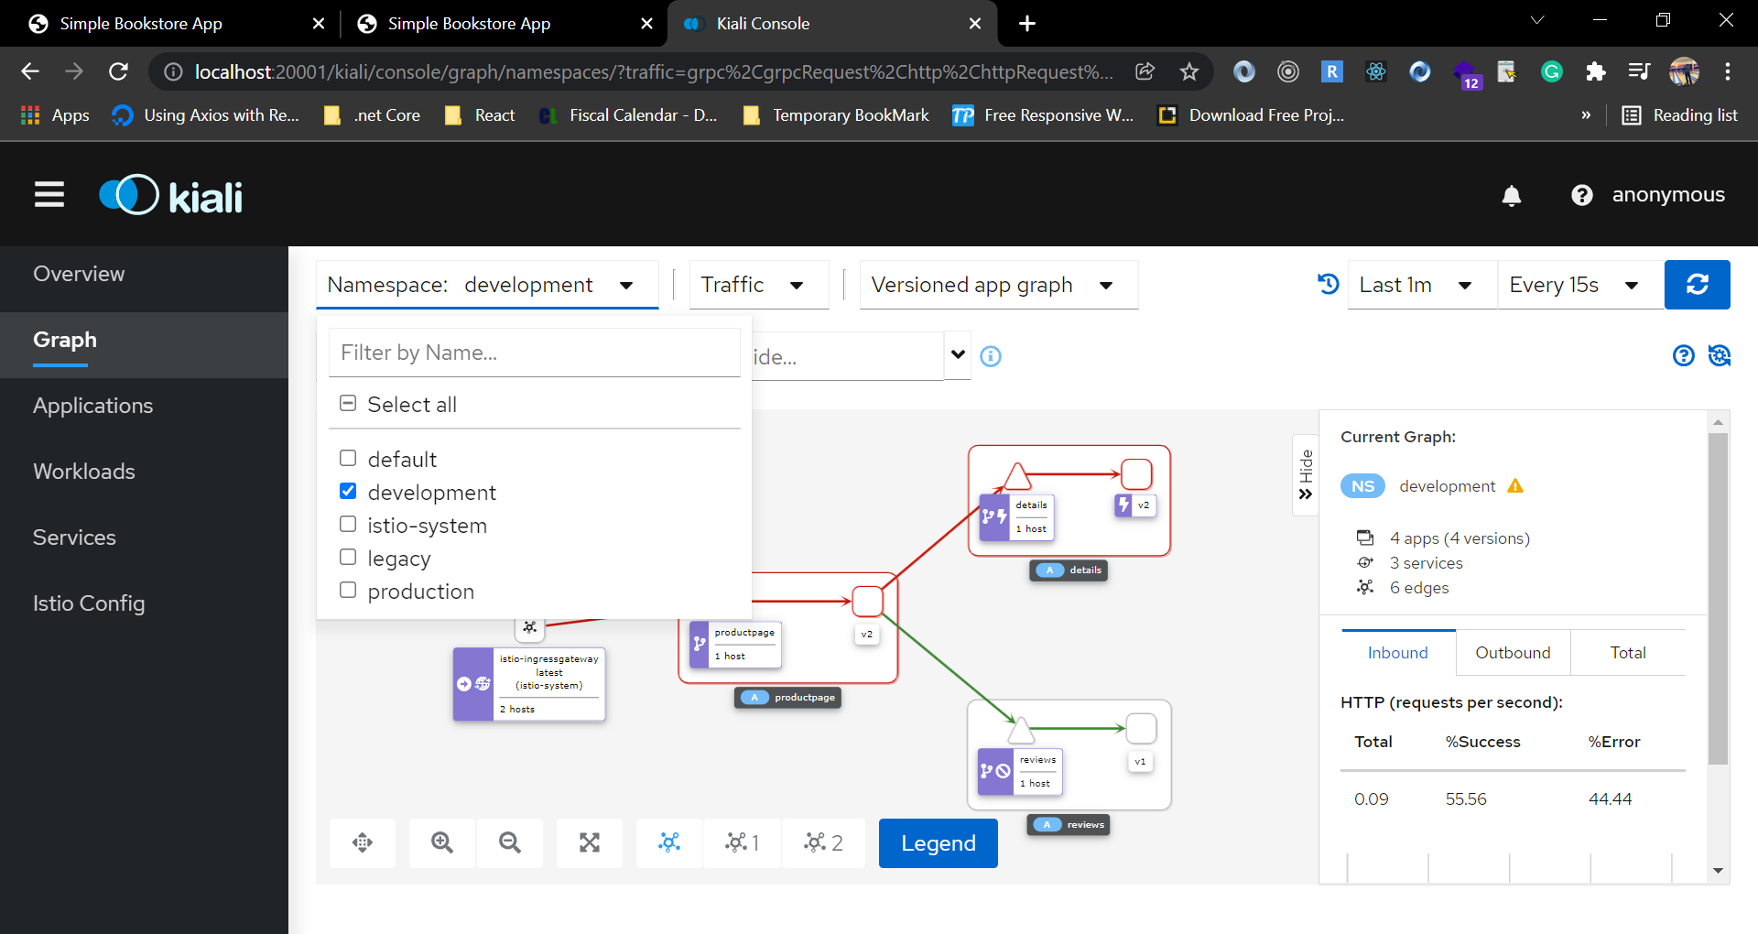

1. We are going to deploy some more pod to get better understanding of the Kiali UI.
2. Create a YAML file and name the file **productpage-v2-canary.yaml** and write below code.

apiVersion: apps/v1

kind: Deployment

metadata:

  name: productpage-v2

  labels:

    app: productpage

    version: v2

spec:

  replicas: 2

  selector:

    matchLabels:

      app: productpage

      version: v2

  template:

    metadata:

      labels:

        app: productpage

        version: v2

    spec:

      serviceAccountName: bookinfo-productpage

      containers:

        - name: productpage

          image: docker.io/sixeyed/bookinfo-productpage:v2

          imagePullPolicy: IfNotPresent

          ports:

            - containerPort: 9080

---

apiVersion: networking.istio.io/v1alpha3

kind: DestinationRule

metadata:

  name: productpage

spec:

  host: productpage

  trafficPolicy:

    tls:

      mode: ISTIO_MUTUAL

  subsets:

    - name: v1

      labels:

        version: v1

    - name: v2

      labels:

        version: v2

---

apiVersion: networking.istio.io/v1alpha3

kind: VirtualService

metadata:

  name: bookinfo

spec:

  hosts:

    - bookinfo.local

  gateways:

    - bookinfo-gateway

  http:

  - route:

    - destination:

        host: productpage

        subset: v1

        port:

          number: 9080

      weight: 70

    - destination:

        host: productpage

        subset: v2

        port:

          number: 9080

      weight: 30

1. Create another YAML file and name the file **reviews-v2-canary.yaml** and write below code.

apiVersion: apps/v1

kind: Deployment

metadata:

  name: reviews-v2

  labels:

    app: reviews

    version: v2

spec:

  replicas: 3

  selector:

    matchLabels:

      app: reviews

      version: v2

  template:

    metadata:

      labels:

        app: reviews

        version: v2

    spec:

      serviceAccountName: bookinfo-reviews

      containers:

        - name: reviews

          image: docker.io/istio/examples-bookinfo-reviews-v2:1.15.0

          imagePullPolicy: IfNotPresent

          ports:

            - containerPort: 9080

---

apiVersion: networking.istio.io/v1alpha3

kind: DestinationRule

metadata:

  name: reviews

spec:

  host: reviews

  trafficPolicy:

    tls:

      mode: ISTIO_MUTUAL

  subsets:

  - name: v1

    labels:

      version: v1

  - name: v2

    labels:

      version: v2

---

apiVersion: networking.istio.io/v1alpha3

kind: VirtualService

metadata:

  name: reviews

spec:

  hosts:

  - reviews

  http:

  - route:

    - destination:

        host: reviews

        subset: v1

      weight: 70

    - destination:

        host: reviews

        subset: v2

      weight: 30

1. Execute above files with below commands.

kubectl apply -f productpage-v2-canary.yaml

kubectl apply -f reviews-v2-canary.yaml

1. Now check on the kiali dashboard. Browse to http://bookinfo.local/productpage and refresh.

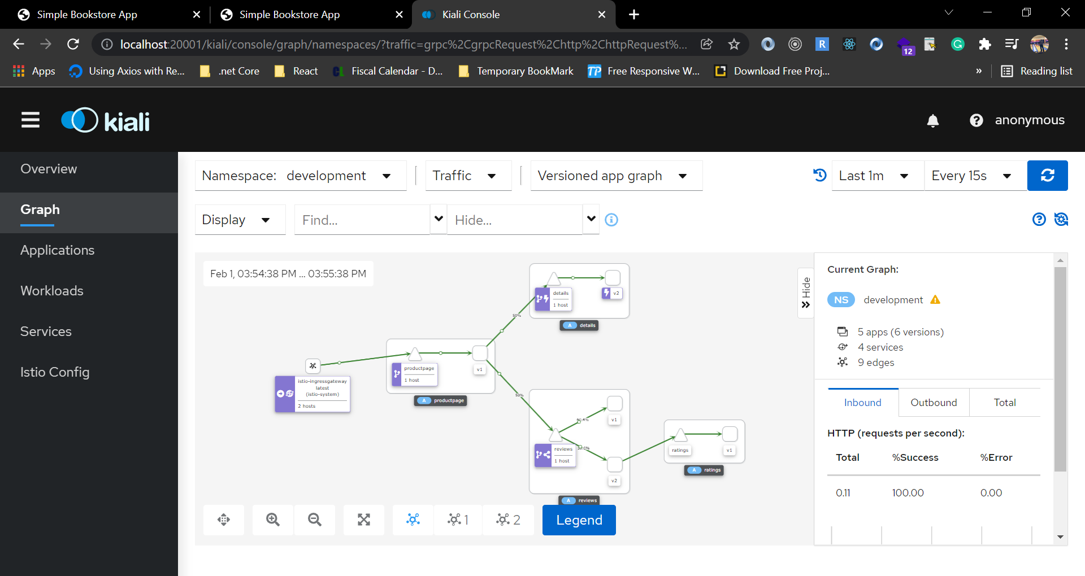

* Back to Kiali
* Switch versioned app graph
* Add Requests percentage label
* Check bookinfo virtual service in Istio Config (editable!)

# Monitoring with Prometheus & Grafana

See the metrics coming into [Prometheus](https://prometheus.io/) and the Istio dashboards in [Grafana](https://grafana.com/" \o "https://grafana.com).

As we have configured earlier, Prometheus and Grafana is already running on pod.

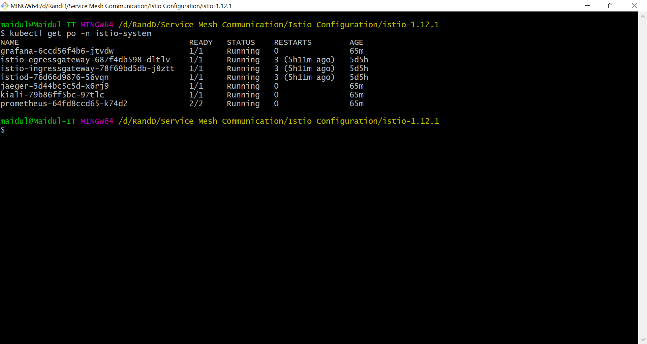

## 1.0 Publish the Prometheus UI

Deploy a Gateway and VirtualService for Prometheus.

1. Create a YAML file and name the file **prometheus.yaml** and write below code.

apiVersion: networking.istio.io/v1alpha3

kind: Gateway

metadata:

  name: prometheus-gateway

  namespace: istio-system

spec:

  selector:

    istio: ingressgateway

  servers:

  - port:

      number: 15030

      name: http-prom

      protocol: HTTP

    hosts:

    - "*"

---

apiVersion: networking.istio.io/v1alpha3

kind: VirtualService

metadata:

  name: prometheus-vs

  namespace: istio-system

spec:

  hosts:

  - "*"

  gateways:

  - prometheus-gateway

  http:

  - match:

    - port: 15030

    route:

    - destination:

        host: prometheus

        port:

          number: 9090

1. Execute the above file with below command.

kubectl apply -f prometheus.yaml

1. Browse to <http://localhost:15030> .
2. Or visit the dashboard with below command on default port.

istioctl dashboard Prometheus

1. Select **istio_requests_total**.
2. Switch to **Graph**.
3. Check Status/Targets - Kubernetes service discovery.

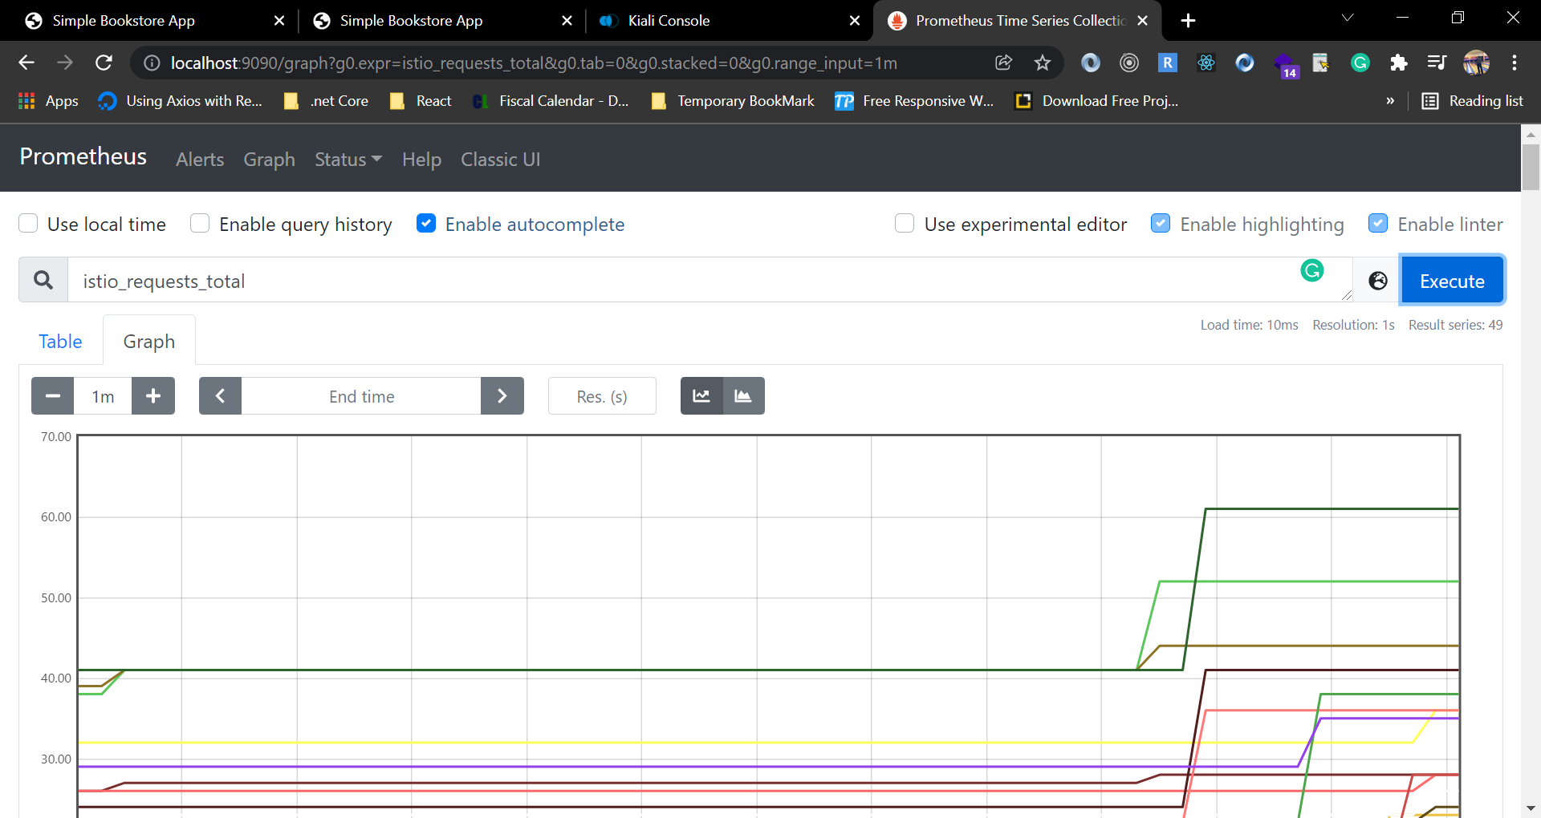

The Prometheus container that’s running actually has serveral responsibilities. It collect metrics, stores them in a time series database.

## 1.2 Publish the Grafana UI

1. Deploy a Gateway and VirtualService for Grafana. Create a YAMl file and name the file **grafana.yaml** and write below code.

apiVersion: networking.istio.io/v1alpha3

kind: Gateway

metadata:

  name: grafana-gateway

  namespace: istio-system

spec:

  selector:

    istio: ingressgateway

  servers:

  - port:

      number: 15031

      name: http-grafana

      protocol: HTTP

    hosts:

    - "*"

---

apiVersion: networking.istio.io/v1alpha3

kind: VirtualService

metadata:

  name: grafana-vs

  namespace: istio-system

spec:

  hosts:

  - "*"

  gateways:

  - grafana-gateway

  http:

  - match:

    - port: 15031

    route:

    - destination:

        host: grafana

        port:

          number: 3000

1. Execute above file with below command.

kubectl apply -f grafana.yaml

1. Browse to <http://localhost:15031> or use below command to acces dashboard with default port.

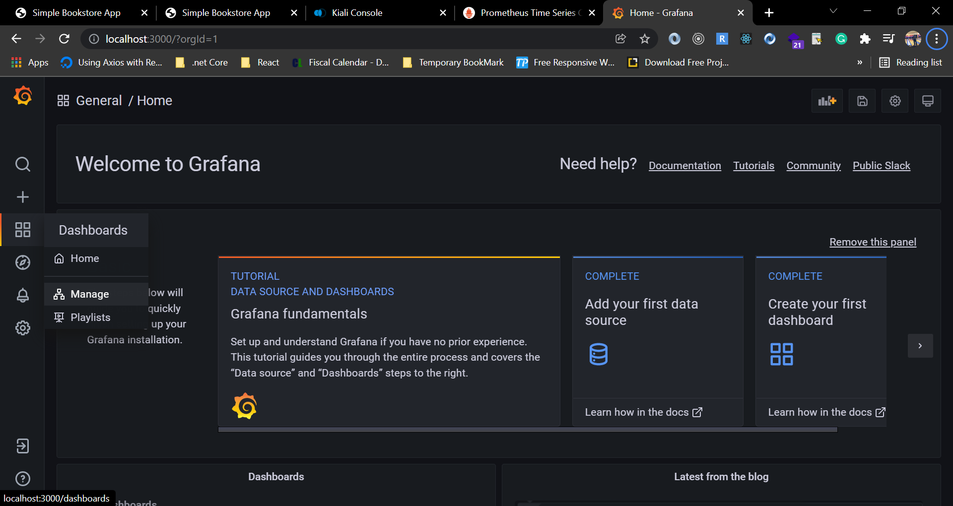

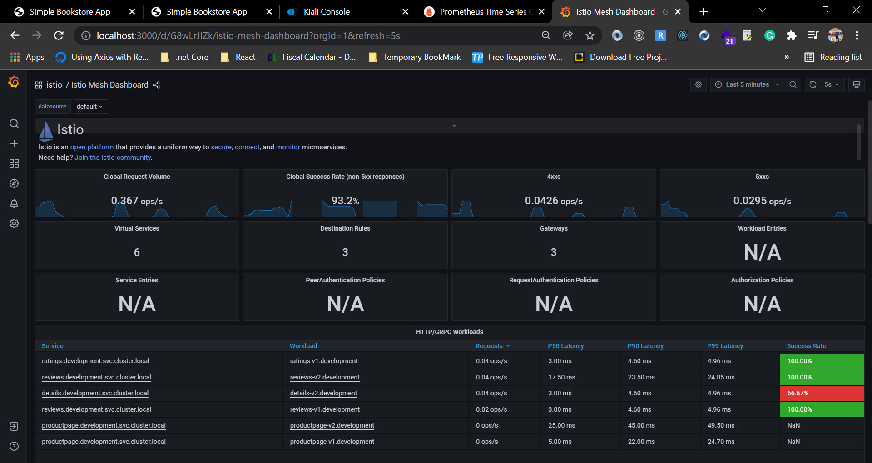

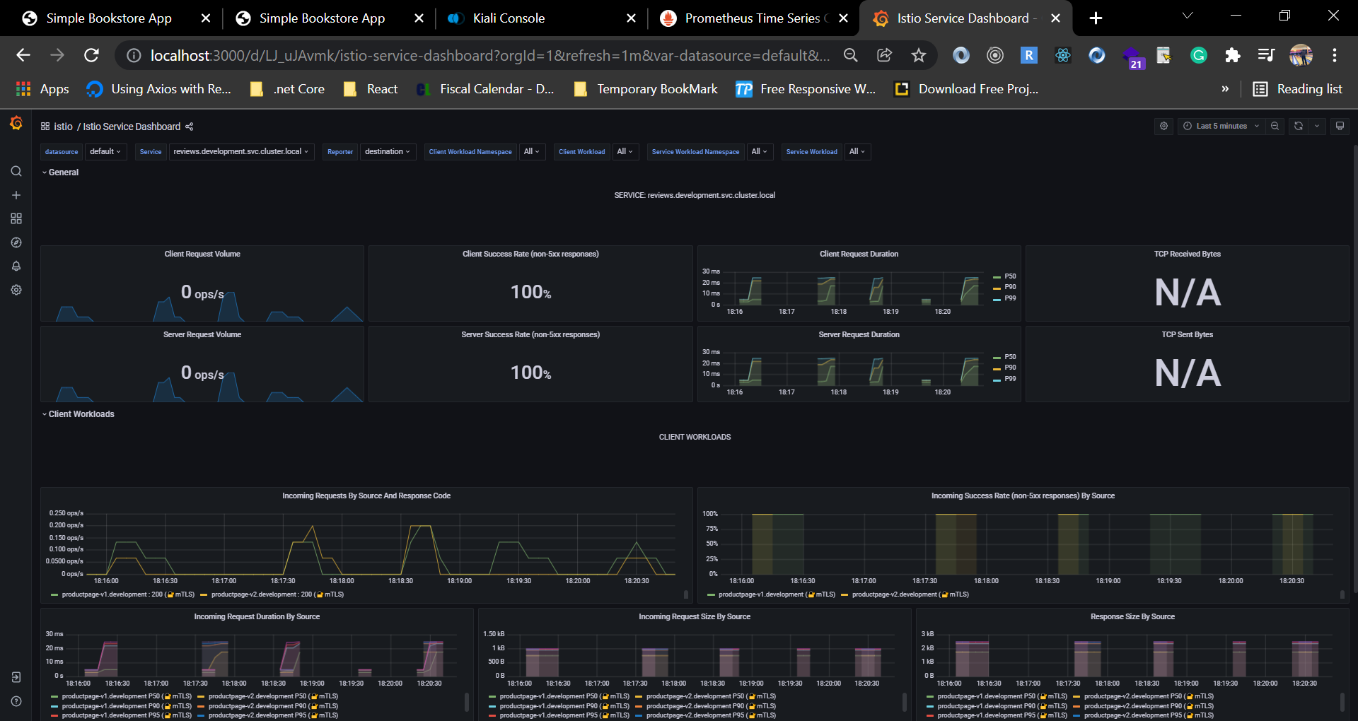

1. Istio Service Dashboard - drill down into service.

# Distributed Tracing

As we have seen that, Observability is not just about attractive dashboards, it is about clear visualization that shows an applications health condition and help to drill down into the detail when things have gone wrong.

Istio uses adapter framework mixer which makes it flexible architecture. It is easy to push different type of telemetry to new backend.

Now we are going to look at is sending trace data to Zipkin. Distributed tracing is a really core part of the observability toolkit during working on micro services.

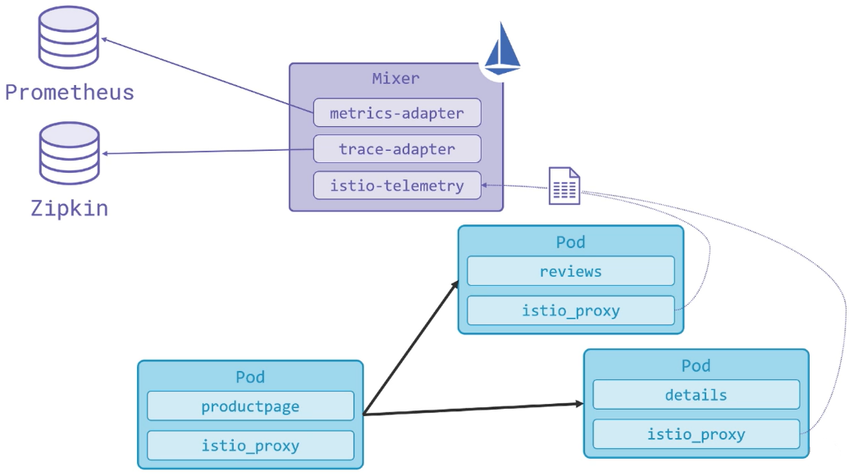

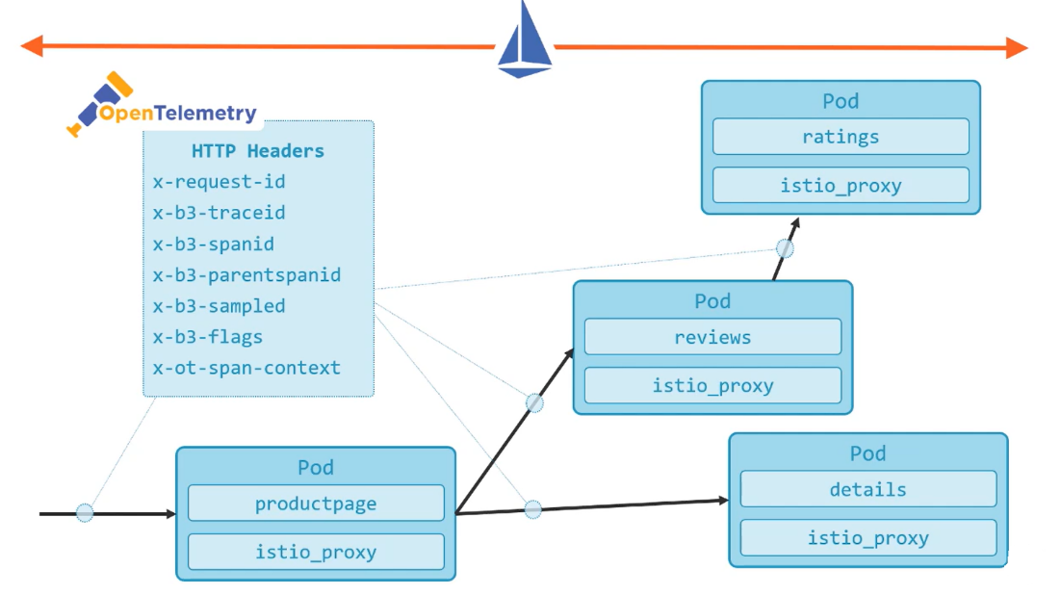

## 1.0 Publish the Jaegar UI

1. Deploy a Gateway and VirtualService for Jaegar. Create a YAML file and name it **jaegar.yaml** and write below code.

apiVersion: networking.istio.io/v1alpha3

kind: Gateway

metadata:

  name: tracing-gateway

  namespace: istio-system

spec:

  selector:

    istio: ingressgateway

  servers:

  - port:

      number: 15032

      name: http-tracing

      protocol: HTTP

    hosts:

    - "*"

---

apiVersion: networking.istio.io/v1alpha3

kind: VirtualService

metadata:

  name: tracing-vs

  namespace: istio-system

spec:

  hosts:

  - "*"

  gateways:

  - tracing-gateway

  http:

  - match:

    - port: 15032

    route:

    - destination:

        host: tracing

        port:

          number: 80

1. Execute the above code with below command.

kubectl apply -f jaegar.yaml

1. Now Browse to <http://localhost:15032> or use below command to access the dashboard with default port.

istioctl dashboard jaeger

1. Select service **productpage.default.**
2. Follow traces - OK & failing.
3. Zoom into timeline & check tags.

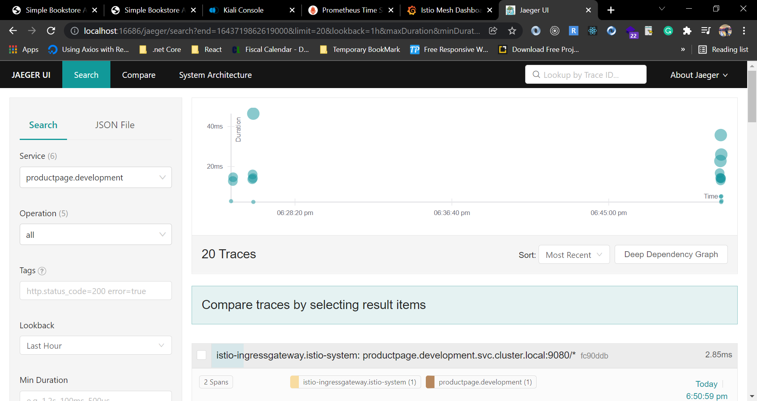

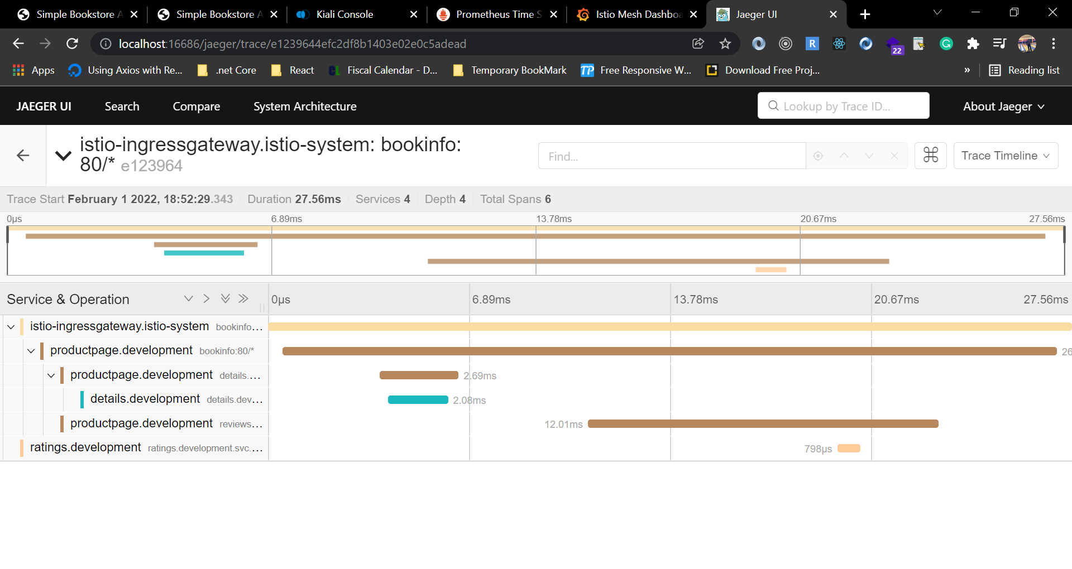

From the above output we can see that the response took almost 28ms and use 4 service call. We can identify latency and which service is causing latency from Jaegar.

# Logging from Istio and Envoy

Use the EFK stack - **Elasticsearch, Fluentd** and **Kibana** to record and search logs.

As we know that tracing is expensive and Istio follows the standard approach of recording sample traces rather than every single trace. We can configure the sampling rate in our deployment and a very low sampling rate by 1% of requests is probably enough to show what is going on without consuming to much compute.

Istio does not come with any logging tool. We need to deploy the logging stack and we will do that using a standard logging stack. We are going to deploy standard EFK stack.

**Elasticsearch**:   
Any time any of our application container write a log entry, it gets collected by FluendD and stored in Elasticsearch and it a document database.

**FluendD:**FluendD is a log collector and we can configure it with kubernetes and it will collect all container logs.

**Kibana:**Log entries can be queried by Kibana from Elasticsearch and it is UI over Elasticsearch.

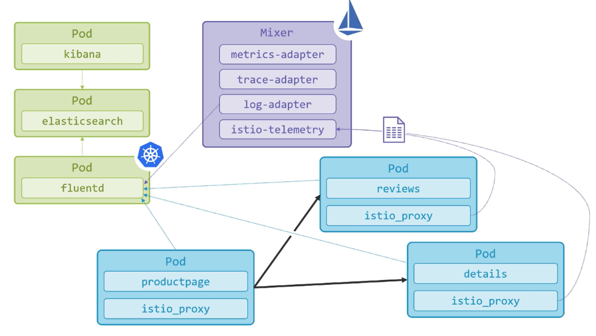

## 1.0 Deploy the Logging Stack

We are going to deploy pods and services of Elasticsearch, Fluentd and Kibana.

1. Create a YAML file and name the file **elasticsearch.yaml**  and write below code.

# Logging Namespace. All below are a part of this namespace.

apiVersion: v1

kind: Namespace

metadata:

  name: logging

---

# Elasticsearch Service

apiVersion: v1

kind: Service

metadata:

  name: elasticsearch

  namespace: logging

  labels:

    app: elasticsearch

spec:

  ports:

  - port: 9200

    protocol: TCP

    targetPort: db

  selector:

    app: elasticsearch

---

# Elasticsearch Deployment

apiVersion: apps/v1

kind: Deployment

metadata:

  name: elasticsearch

  namespace: logging

  labels:

    app: elasticsearch

spec:

  replicas: 1

  selector:

    matchLabels:

      app: elasticsearch

  template:

    metadata:

      labels:

        app: elasticsearch

      annotations:

        sidecar.istio.io/inject: "false"

    spec:

      containers:

      - image: docker.elastic.co/elasticsearch/elasticsearch-oss:6.1.1

        name: elasticsearch

        resources:

          # need more cpu upon initialization, therefore burstable class

          limits:

            cpu: 1000m

          requests:

            cpu: 100m

        env:

          - name: discovery.type

            value: single-node

        ports:

        - containerPort: 9200

          name: db

          protocol: TCP

        - containerPort: 9300

          name: transport

          protocol: TCP

        volumeMounts:

        - name: elasticsearch

          mountPath: /data

      volumes:

      - name: elasticsearch

        emptyDir: {}

1. Create a YAML file and name the file **kibana.yaml**  and write below code.

# Kibana Service

apiVersion: v1

kind: Service

metadata:

  name: kibana

  namespace: logging

  labels:

    app: kibana

spec:

  ports:

  - port: 5601

    protocol: TCP

    targetPort: ui

  selector:

    app: kibana

---

# Kibana Deployment

apiVersion: apps/v1

kind: Deployment

metadata:

  name: kibana

  namespace: logging

  labels:

    app: kibana

spec:

  replicas: 1

  selector:

    matchLabels:

      app: kibana

  template:

    metadata:

      labels:

        app: kibana

      annotations:

        sidecar.istio.io/inject: "false"

    spec:

      containers:

      - name: kibana

        image: docker.elastic.co/kibana/kibana-oss:6.1.1

        resources:

          # need more cpu upon initialization, therefore burstable class

          limits:

            cpu: 1000m

          requests:

            cpu: 100m

        env:

          - name: ELASTICSEARCH_URL

            value: http://elasticsearch:9200

        ports:

        - containerPort: 5601

          name: ui

          protocol: TCP

---

apiVersion: networking.istio.io/v1alpha3

kind: Gateway

metadata:

  name: kibana-gateway

  namespace: logging

spec:

  selector:

    istio: ingressgateway

  servers:

  - port:

      number: 15033

      name: http-kibana

      protocol: HTTP

    hosts:

    - "*"

---

apiVersion: networking.istio.io/v1alpha3

kind: VirtualService

metadata:

  name: kibana-vs

  namespace: logging

spec:

  hosts:

  - "*"

  gateways:

  - kibana-gateway

  http:

  - match:

    - port: 15033

    route:

    - destination:

        host: kibana

        port:

          number: 5601

1. Create a YAML file and name the file **fluentd.yaml** and write below code.

apiVersion: v1

kind: ServiceAccount

metadata:

  name: fluentd

  namespace: kube-system

---

apiVersion: rbac.authorization.k8s.io/v1

kind: ClusterRole

metadata:

  name: fluentd

  namespace: kube-system

rules:

  - apiGroups:

      - ""

    resources:

      - pods

      - namespaces

    verbs:

      - get

      - list

      - watch

---

kind: ClusterRoleBinding

apiVersion: rbac.authorization.k8s.io/v1

metadata:

  name: fluentd

roleRef:

  kind: ClusterRole

  name: fluentd

  apiGroup: rbac.authorization.k8s.io

subjects:

  - kind: ServiceAccount

    name: fluentd

    namespace: kube-system

---

# Fluentd Service

apiVersion: v1

kind: Service

metadata:

  name: fluentd-es

  namespace: kube-system

  labels:

    app: fluentd-es

spec:

  ports:

    - name: fluentd-tcp

      port: 24224

      protocol: TCP

      targetPort: 24224

    - name: fluentd-udp

      port: 24224

      protocol: UDP

      targetPort: 24224

  selector:

    k8s-app: fluentd-logging

---

apiVersion: apps/v1

kind: DaemonSet

metadata:

  name: fluentd

  namespace: kube-system

  labels:

    k8s-app: fluentd-logging

    version: v1

    kubernetes.io/cluster-service: "true"

spec:

  selector:

    matchLabels:

      k8s-app: fluentd-logging

  template:

    metadata:

      labels:

        k8s-app: fluentd-logging

        version: v1

        kubernetes.io/cluster-service: "true"

    spec:

      serviceAccount: fluentd

      serviceAccountName: fluentd

      tolerations:

        - key: node-role.kubernetes.io/master

          effect: NoSchedule

      containers:

        - name: fluentd

          image: fluent/fluentd-kubernetes-daemonset:v1.3-debian-elasticsearch

          env:

            - name: FLUENT_ELASTICSEARCH_HOST

              value: "elasticsearch.logging"

            - name: FLUENT_ELASTICSEARCH_PORT

              value: "9200"

            - name: FLUENT_ELASTICSEARCH_SCHEME

              value: "http"

            - name: FLUENT_UID

              value: "0"

          resources:

            limits:

              memory: 200Mi

            requests:

              cpu: 100m

              memory: 200Mi

          volumeMounts:

            - name: varlog

              mountPath: /var/log

            - name: varlibdockercontainers

              mountPath: /var/lib/docker/containers

              readOnly: true

      terminationGracePeriodSeconds: 30

      volumes:

        - name: varlog

          hostPath:

            path: /var/log

        - name: varlibdockercontainers

          hostPath:

            path: /var/lib/docker/containers

1. Now execute all above file with below commands.

kubectl apply -f elasticsearch.yaml

kubectl apply -f kibana.yaml

kubectl apply -f fluentd.yaml

kubectl get pods -n logging

1. Browse to Kibana at <http://localhost:15033>. Or if you are using docker desktop you can use below command to port forward.

kubectl port-forward svc/kibana 8001:5601 -n logging

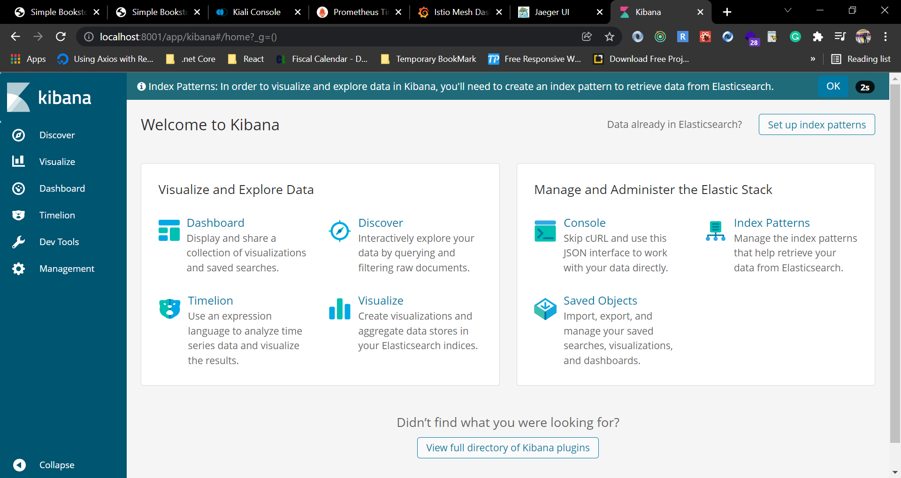

1. In Discover create index pattern for **logstash*.**

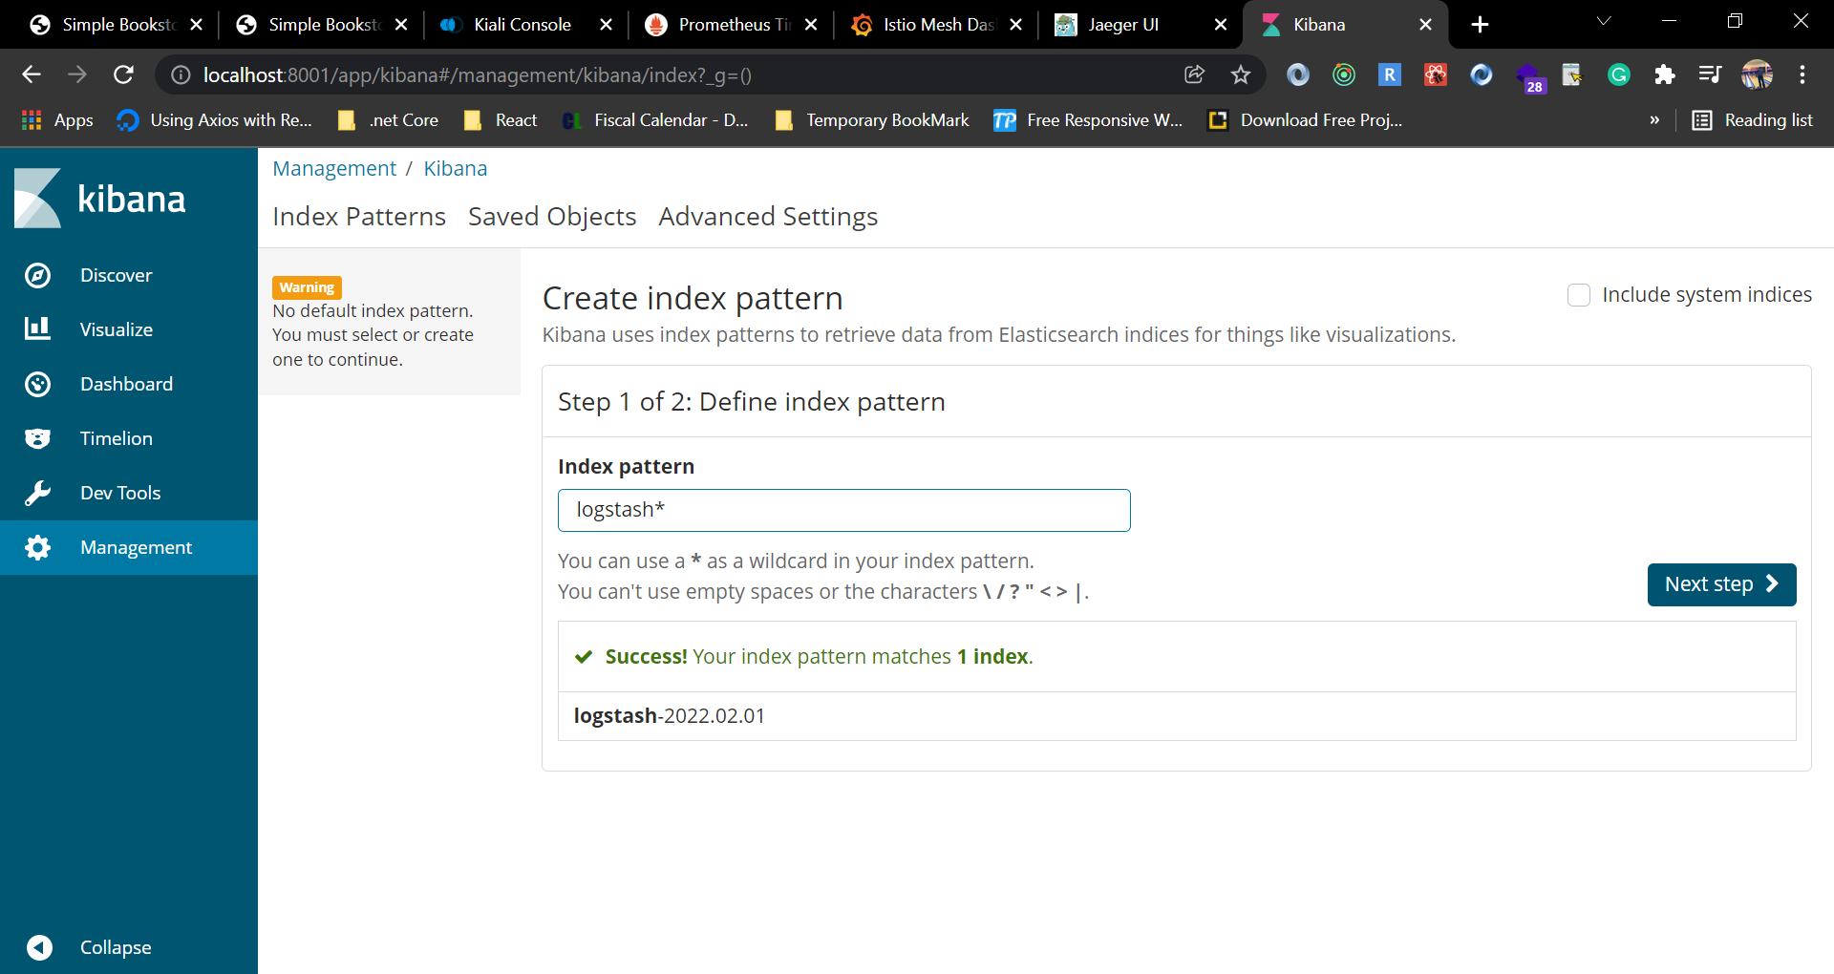

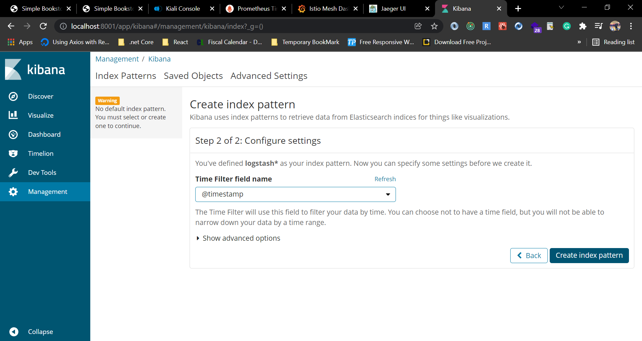

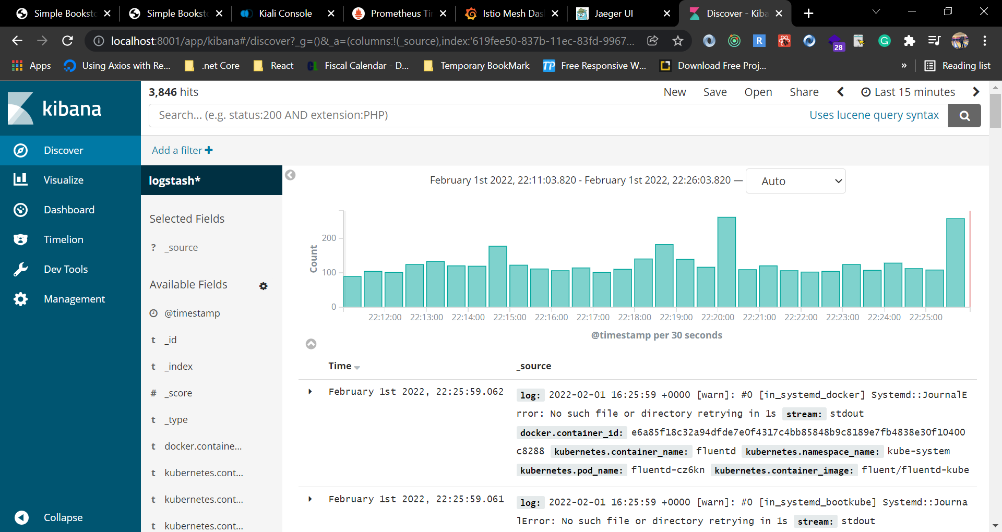

In the discover section we can see all logs from containers.

1. We can filter on **kubernetes.labels.app** is **productpage.**

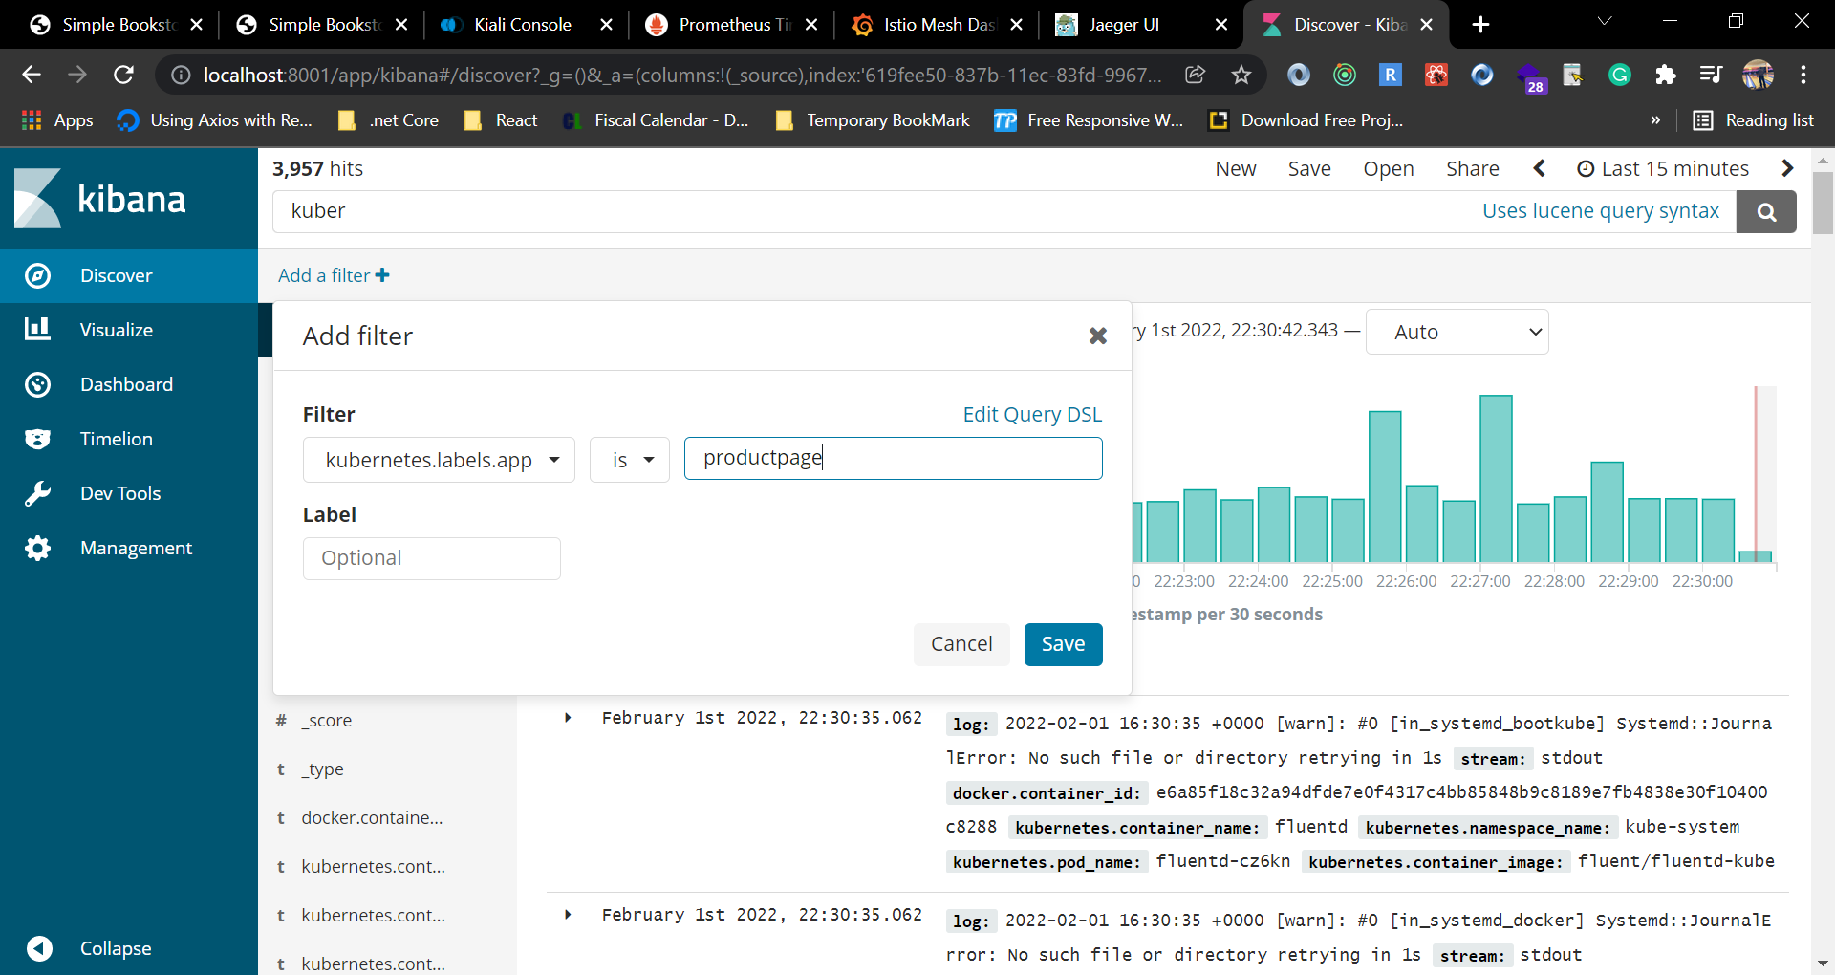

## 1.1 Configure Istio to Log to Fluentd

Now we are going to configure Istio to use the same FluentD instance, and send proxy logs through FluentD into Elasticsearch.

It will be actual adapter configuration that I mentioned earler.

1. Create a YAMl file and name the file **fluentd-istio.yaml** and write below code.

# Configuration for logentry instances

apiVersion: config.istio.io/v1alpha2

kind: instance

metadata:

  name: newlog

  namespace: istio-system

spec:

  compiledTemplate: logentry

  params:

    severity: '"info"'

    timestamp: request.time

    variables:

      source: source.labels["app"] | source.workload.name | "unknown"

      user: source.user | "unknown"

      destination: destination.labels["app"] | destination.workload.name | "unknown"

      responseCode: response.code | 0

      responseSize: response.size | 0

      latency: response.duration | "0ms"

    monitored_resource_type: '"UNSPECIFIED"'

---

# Configuration for a Fluentd handler

apiVersion: config.istio.io/v1alpha2

kind: handler

metadata:

  name: handler

  namespace: istio-system

spec:

  compiledAdapter: fluentd

  params:

    address: "fluentd-es.kube-system:24224"

---

# Rule to send logentry instances to the Fluentd handler

apiVersion: config.istio.io/v1alpha2

kind: rule

metadata:

  name: newlogtofluentd

  namespace: istio-system

spec:

  match: "true" # match for all requests

  actions:

   - handler: handler

     instances:

     - newlog

---

1. Filter on search with **kubernetes.container.name is istio-proxy**  and we will see logs fron istio proxy.

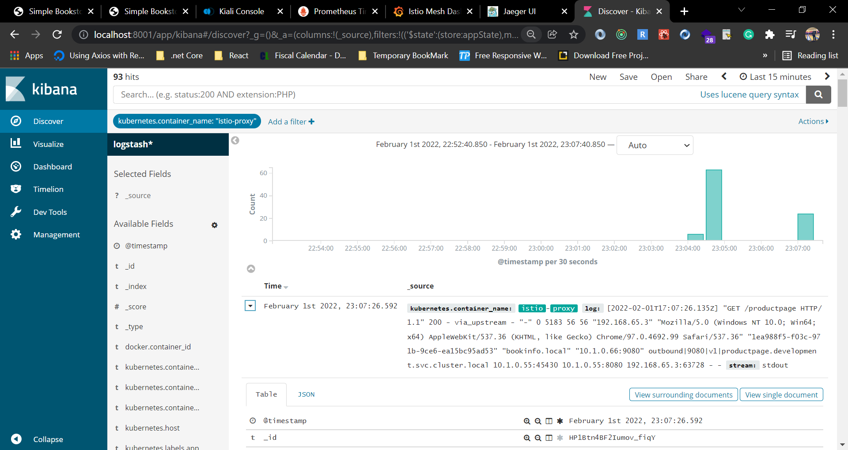

# References

<https://istio.io/latest/docs/setup/getting-started/>

<https://github.com/istio/istio/releases/tag/1.12.2>

<https://kubernetes.io/docs/concepts/overview/working-with-objects/namespaces/>

<https://www.redhat.com/en/topics/microservices/what-is-a-service-mesh>

<https://www.nginx.com/blog/what-is-a-service-mesh/>

<https://kiali.io/docs/installation/quick-start/>

<https://prometheus.io/docs/prometheus/latest/getting_started/>

<https://grafana.com/>

<https://www.elastic.co/>

<https://www.digitalocean.com/community/tutorials/how-to-set-up-an-elasticsearch-fluentd-and-kibana-efk-logging-stack-on-kubernetes>